# R Basics

## Factor Function

### Usage of the Factor Function – Aggrupation

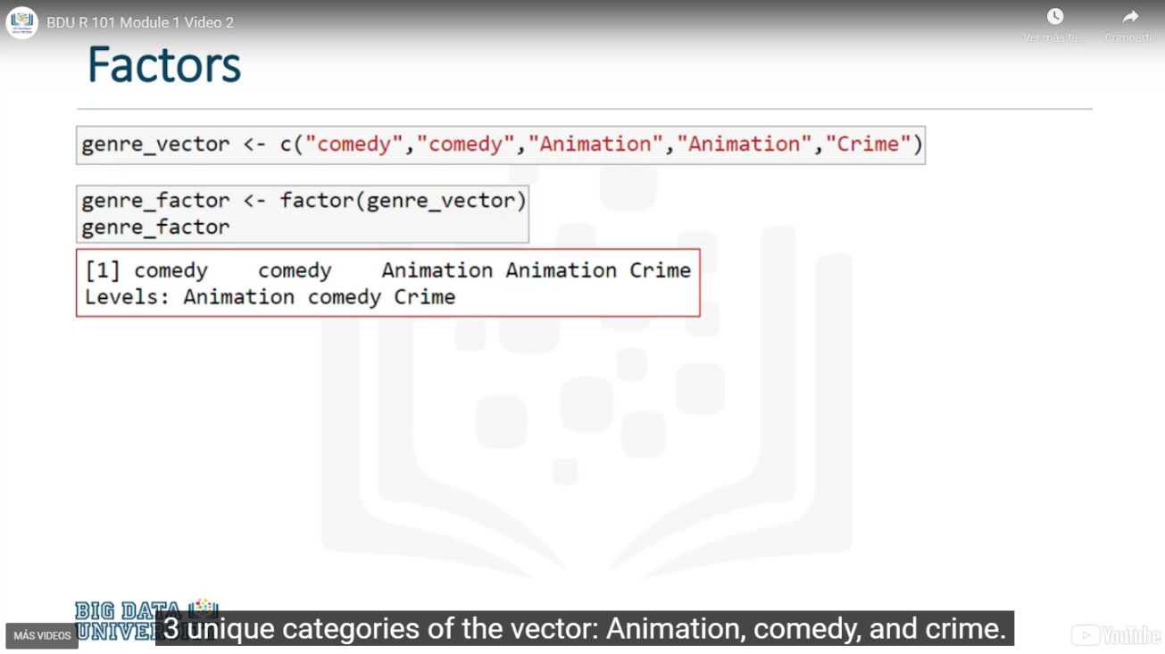

### Summarizing factors

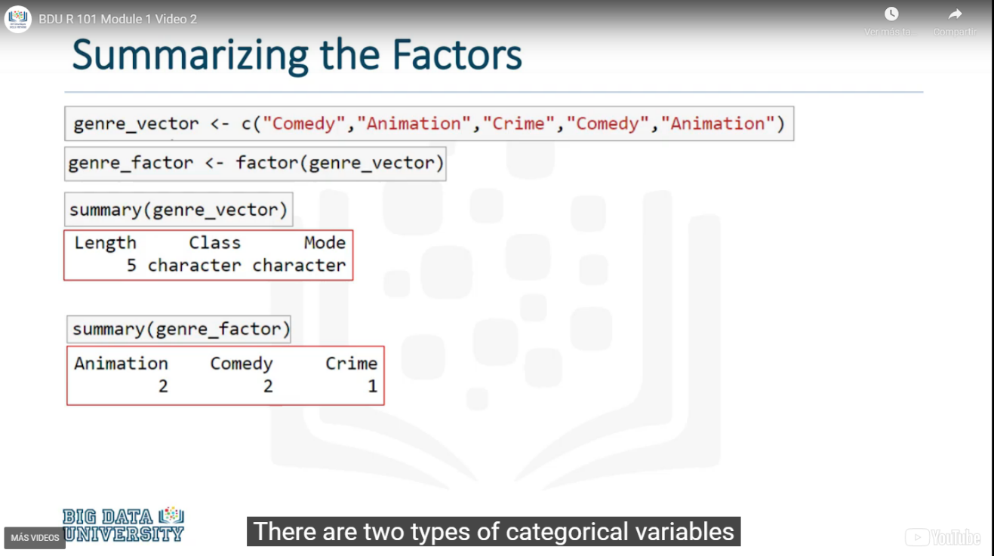

### Ordering factors

Nominal Categorical Variable – does not have any implied order

Ordinal Variable – it does have an specific order

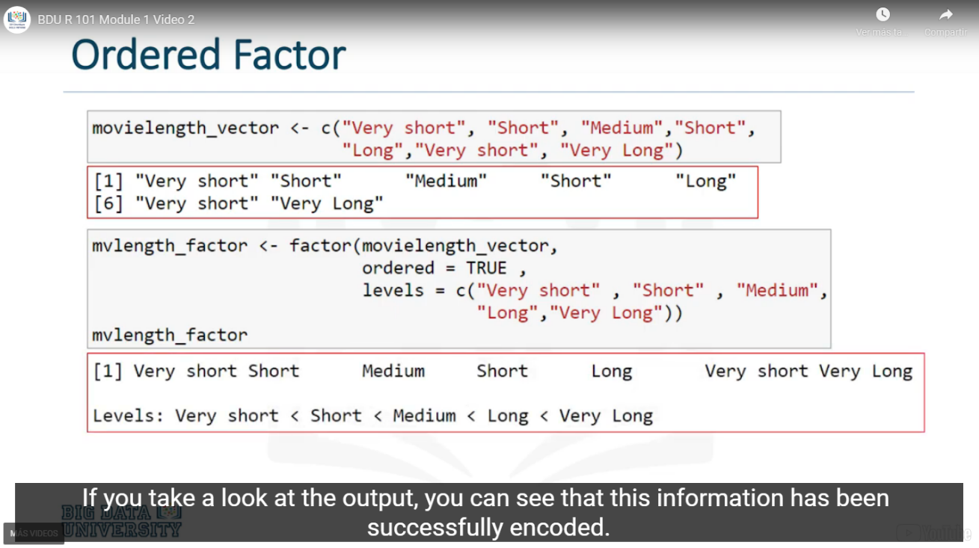

## Vector Operations

### Types of Vectors

Hay tres tipos de vectores:

* Numéricos: “1 2 3 4 5 6”
* De caracteres: “Toy Story”
* Lógico: TRUE FALSE

### Naming Elements of a Vector: names(vector) - names(year)

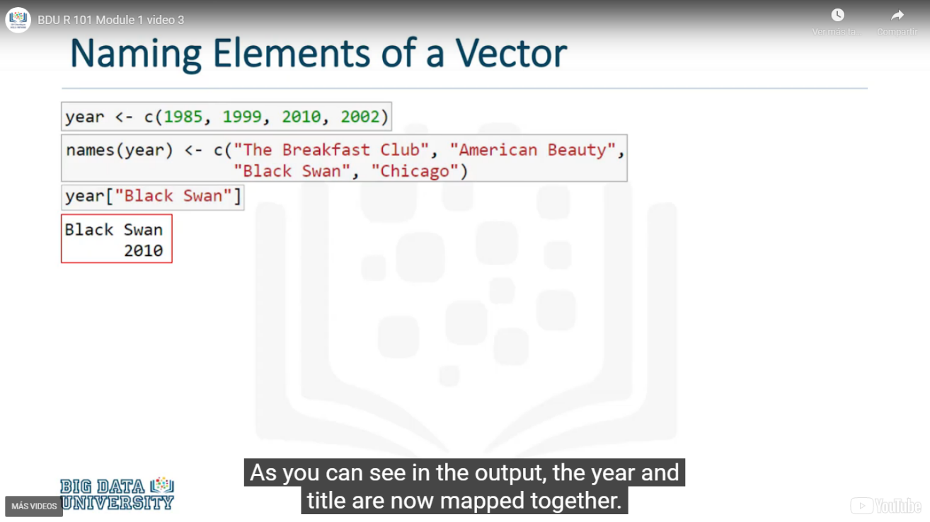

### Length a Vector: length(vector) - length(year)

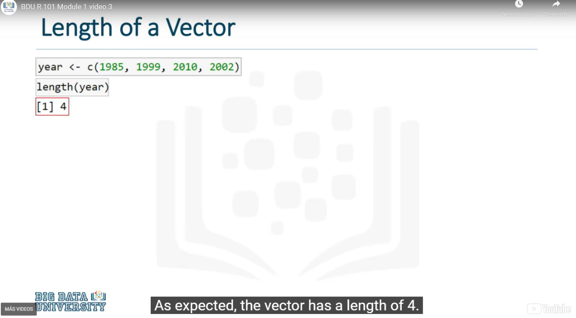

### Sort a Vector: sort(vector) - sort(year)

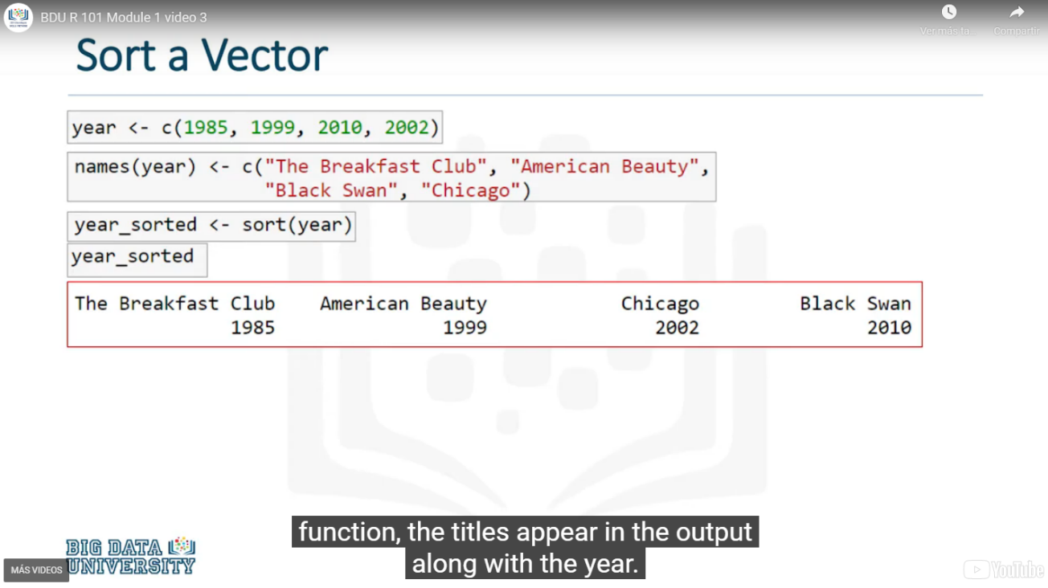

### Finding smallest and largest number: max(vector) min(vector) – max(cost) min(cost)

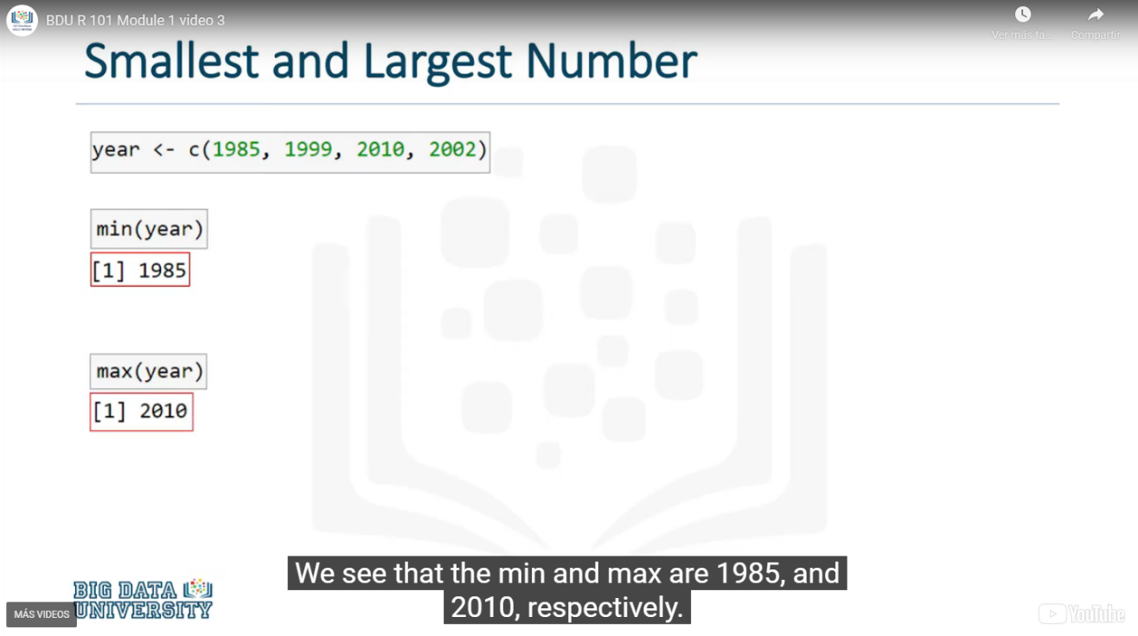

### Average of Numbers: mean(vector) – mean (cost)

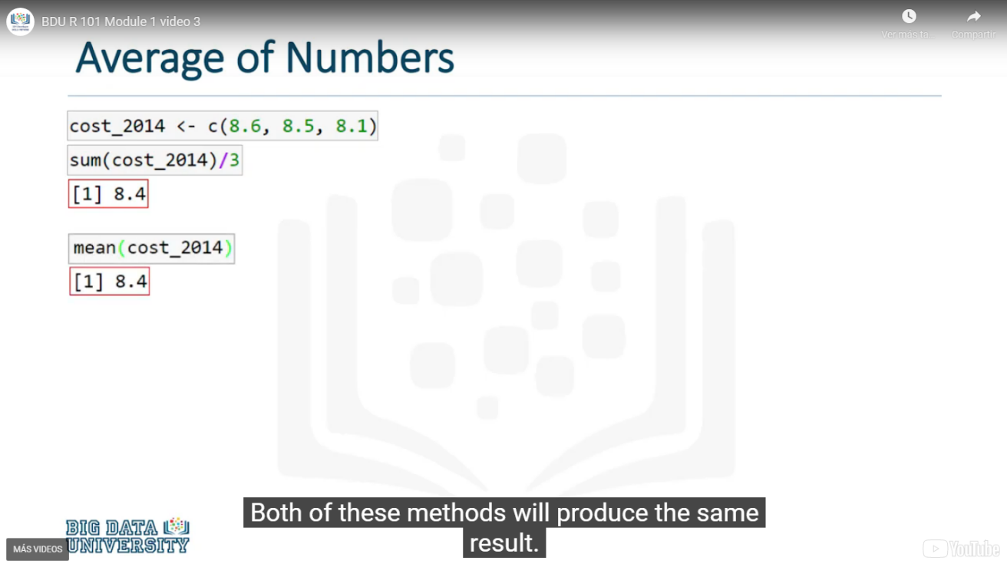

### Vector Summary and Descriptive Statistics: summary(vector) – summary (cost)

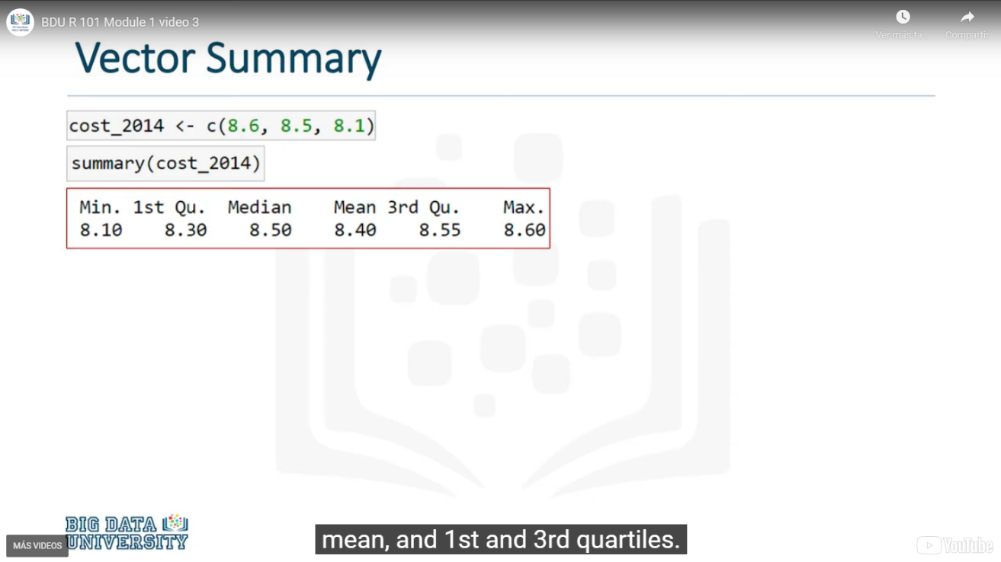

### Vector Index, choosing one or more elements of a Vector: vector[]

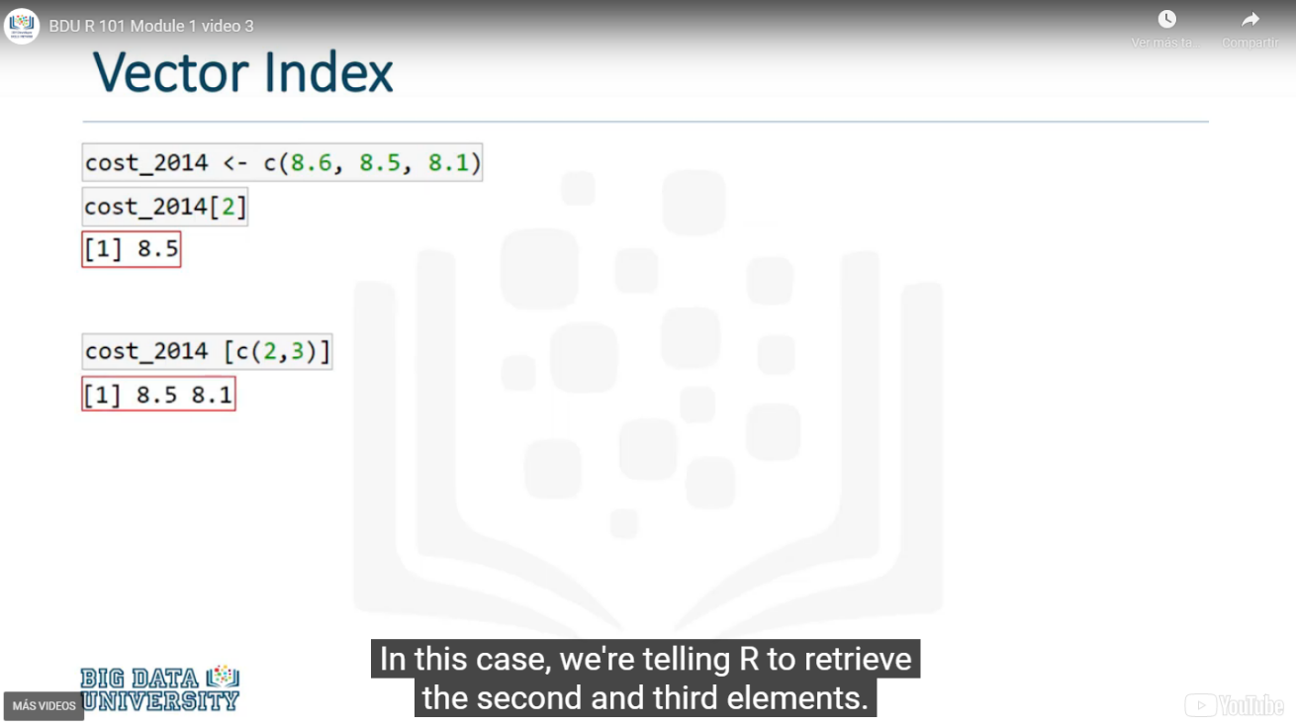

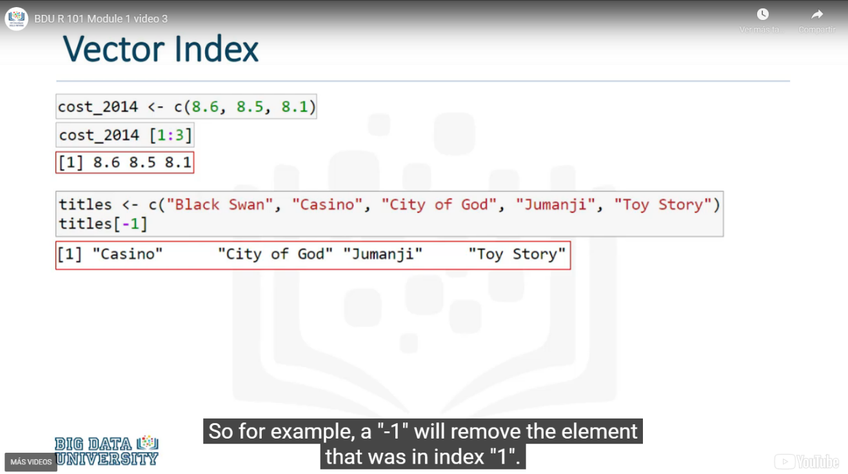

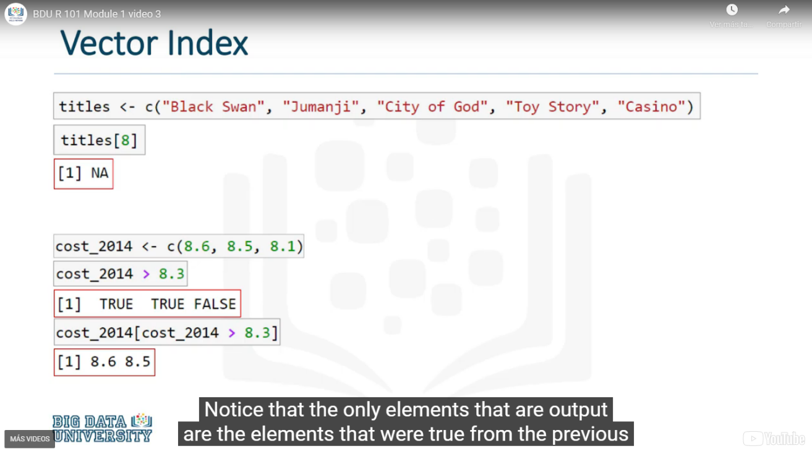

### Vector Arithmetic. Multiply, divide and group results in a vector

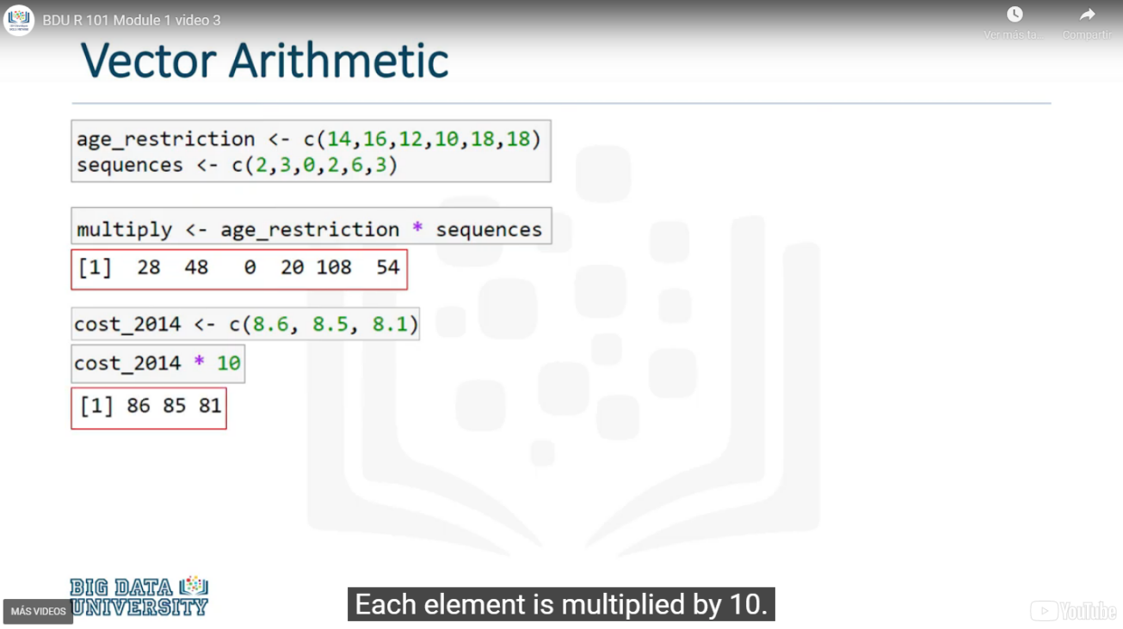

# Data Structures

## Arrays and Matrix

### Array Command: array(vector)

An array is a structure that contains data of the same type, whether that's strings, or characters, or integers.

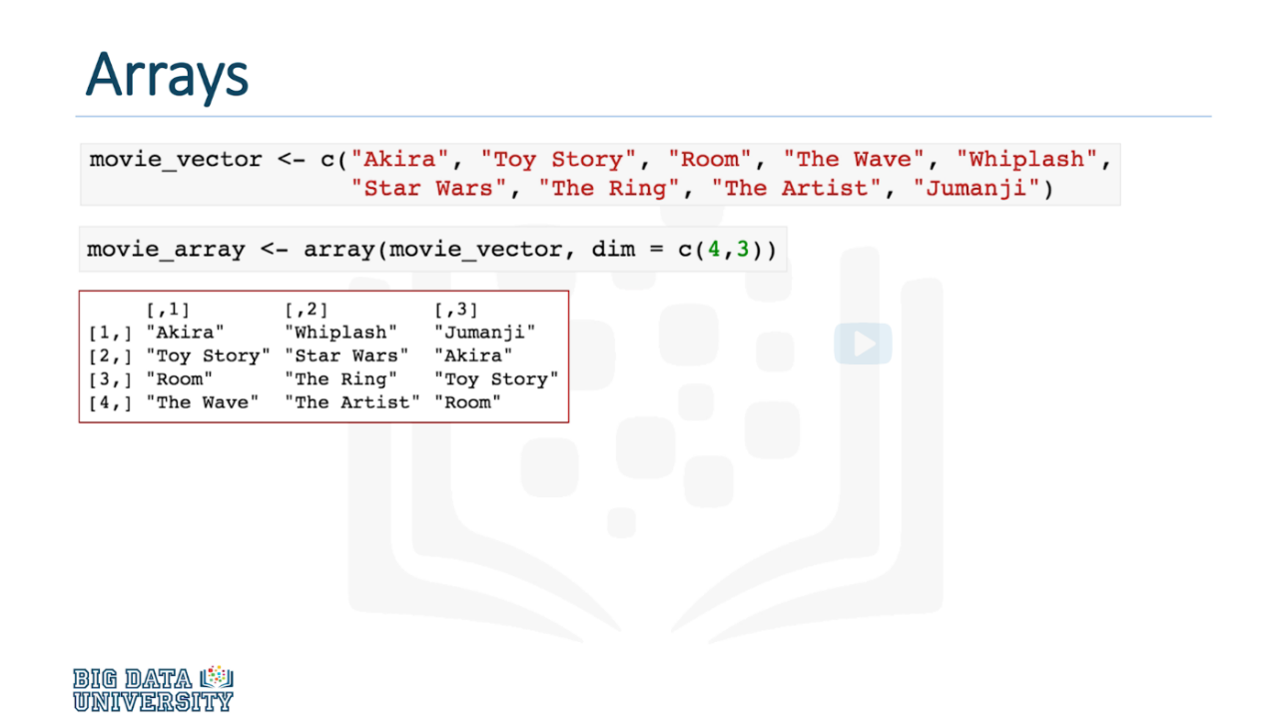

### Accessing an Array

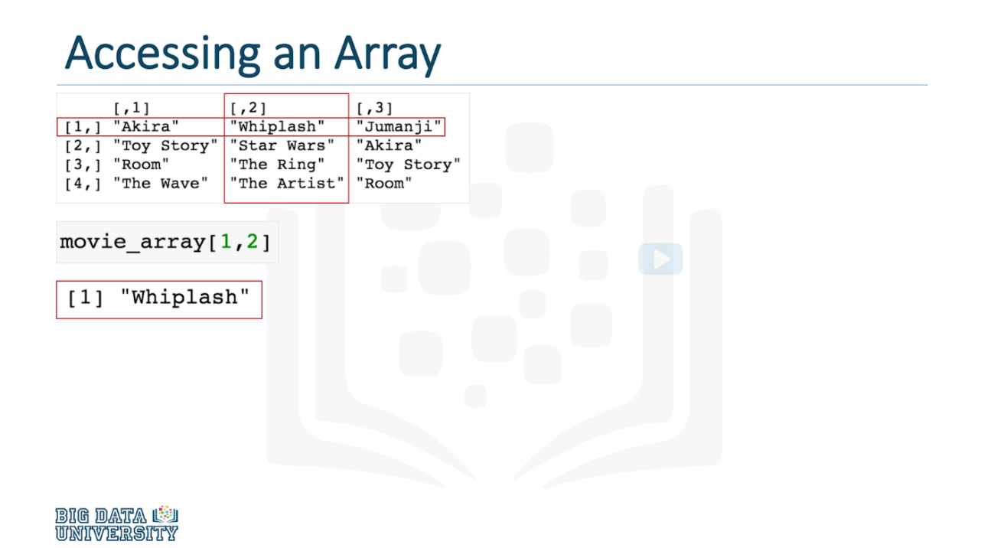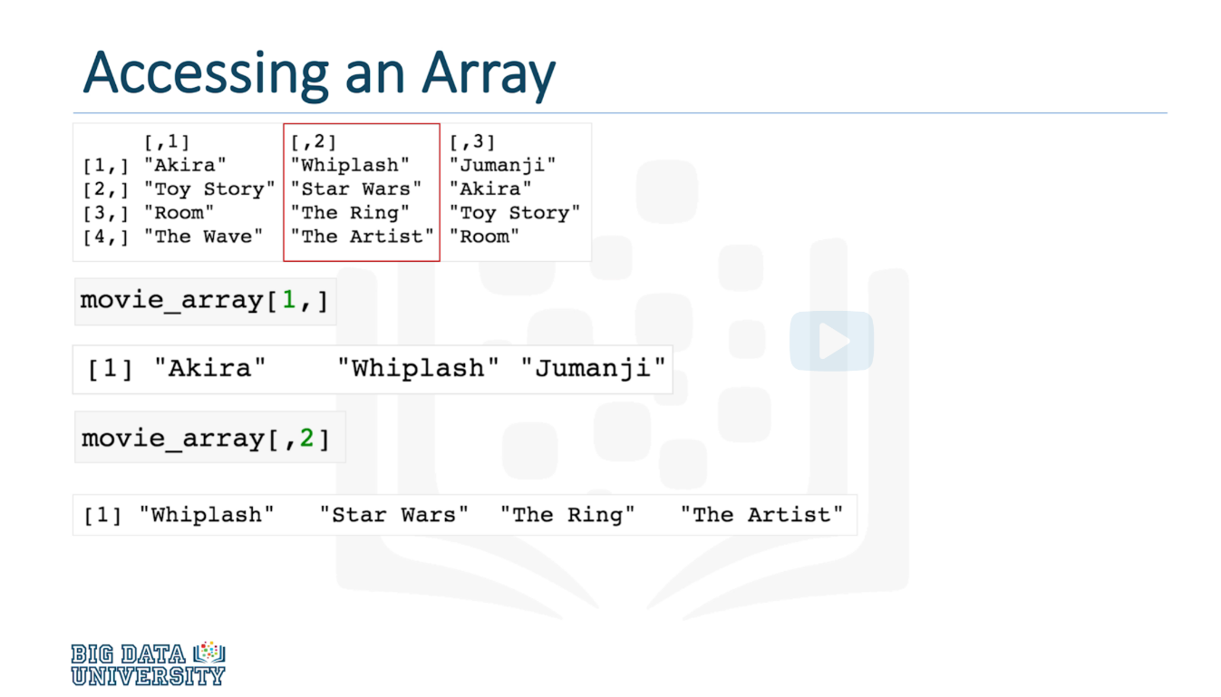

### Matrix Command: matrix(vector)

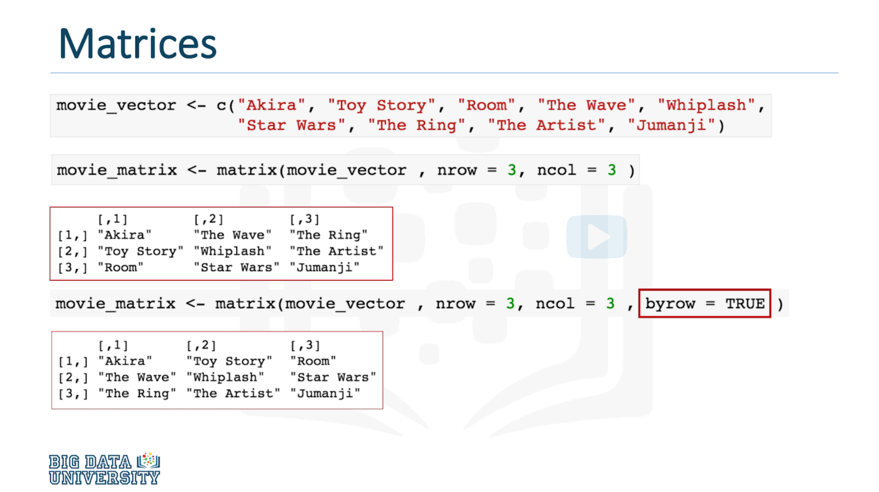

### Accessing a Matrix

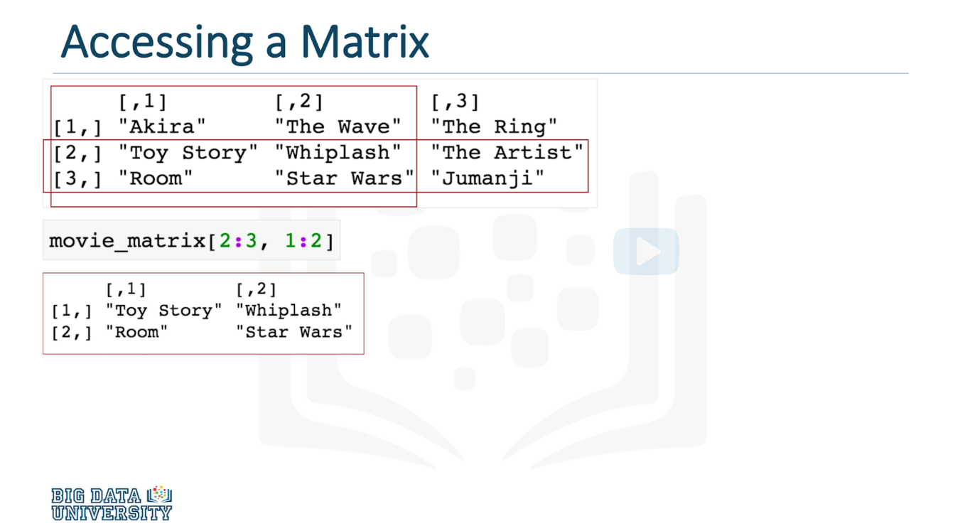

## Lists

In R, a list is a collection of objects, similar to a vector. But unlike a vector, the elements inside of a list can differ in terms of data type. A list is a sequenced collection of different objects of R, like vectors, numbers, characters, other lists as well, and so on.

### Accessing Items in a List

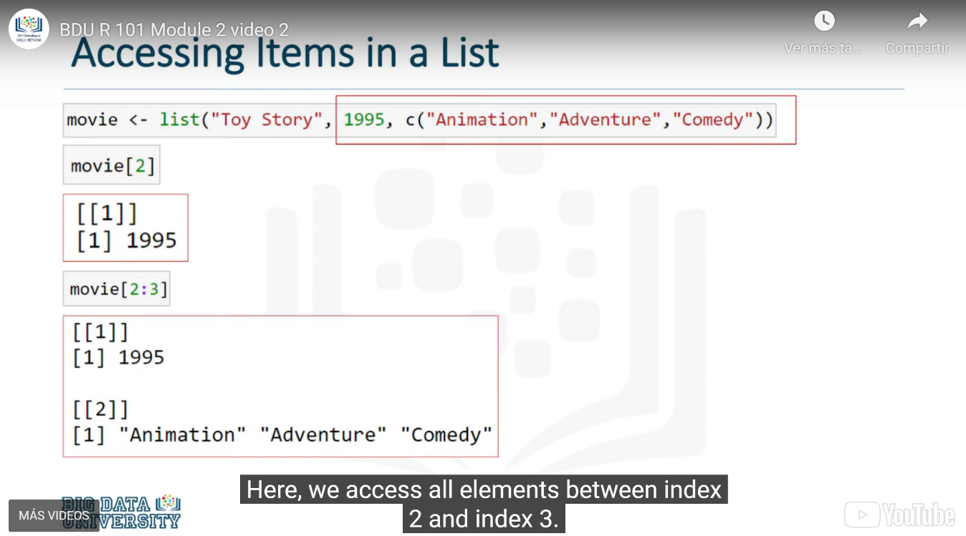

### Naming Lists

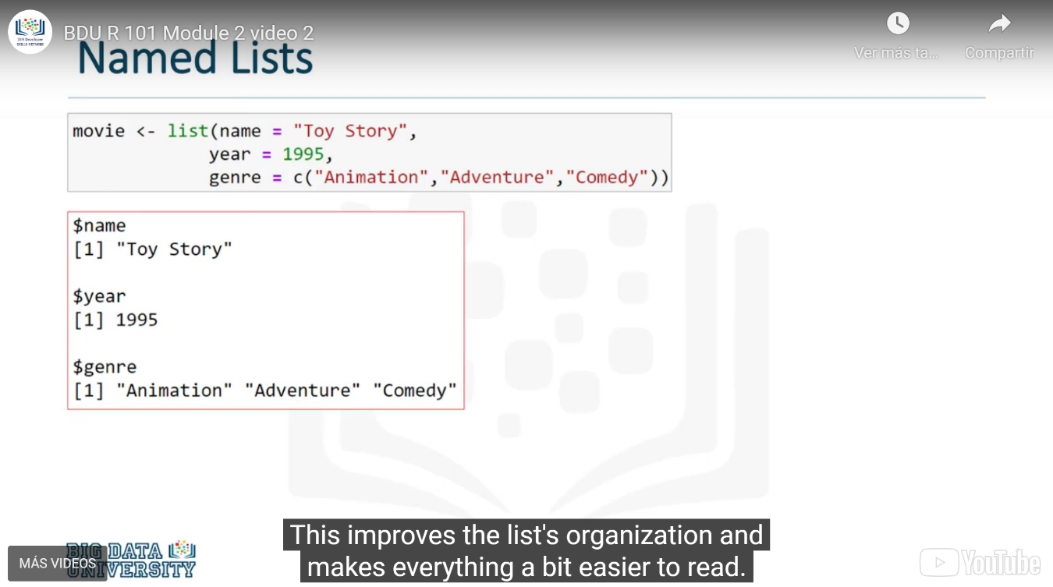

### Accesing Named Lists

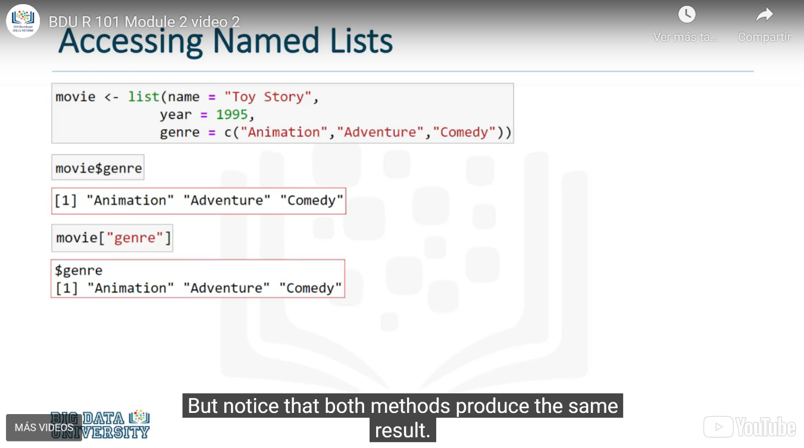

### Adding Items to a list

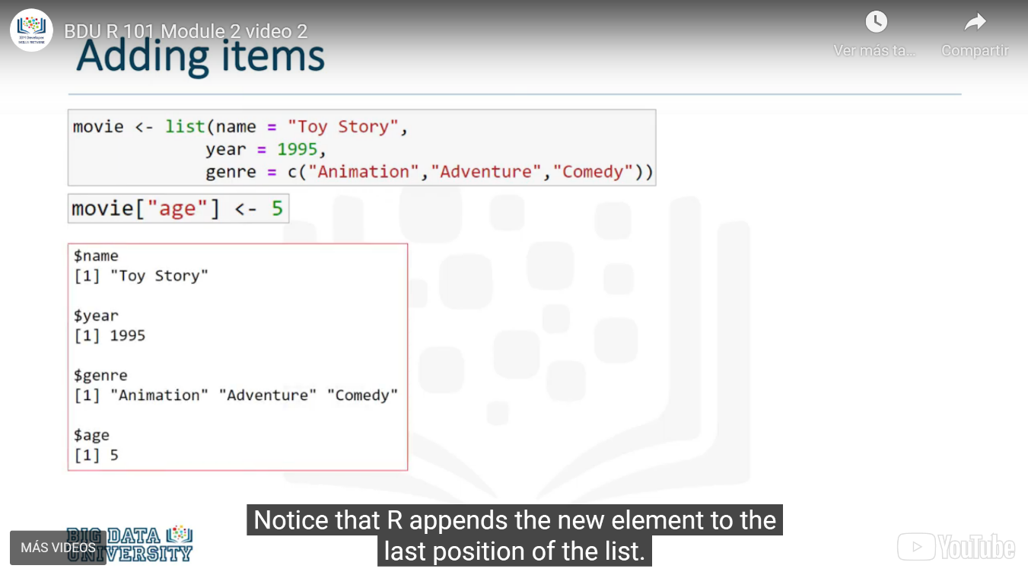

### Modifying items in a list

To overwrite an existing value…

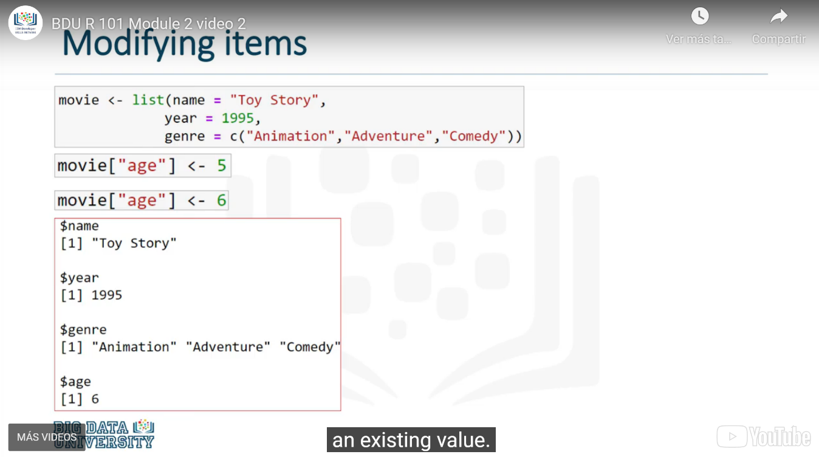

### Remove items from a list

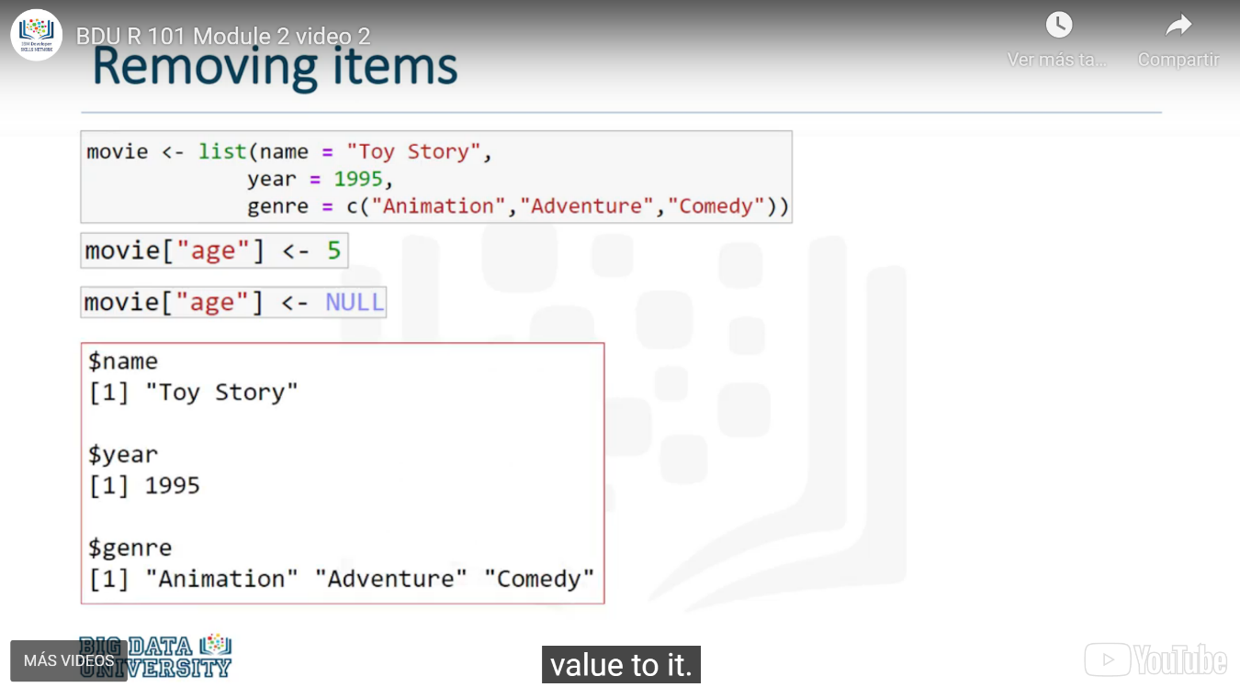

## Dataframes

### What is a data frame?

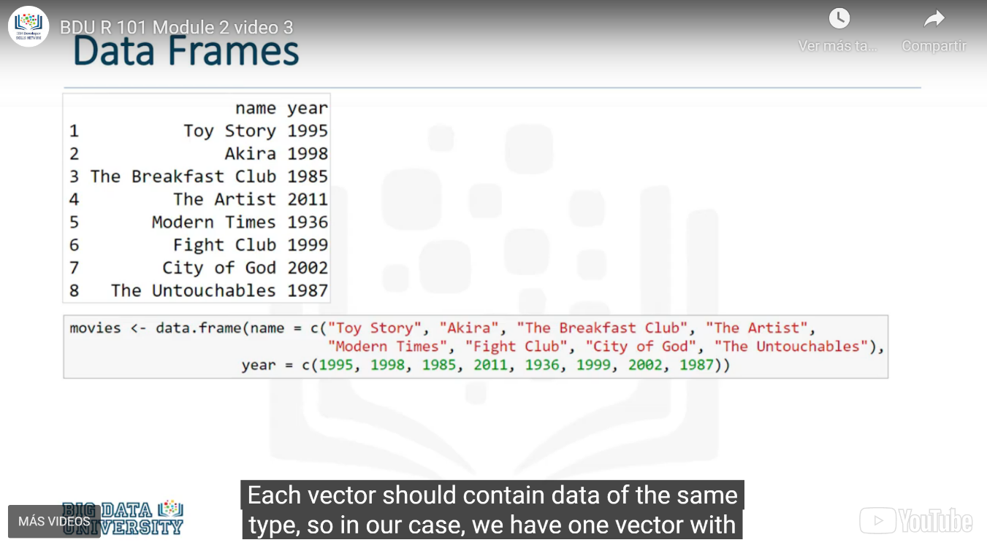

### Getting specific elements of a Data Frame

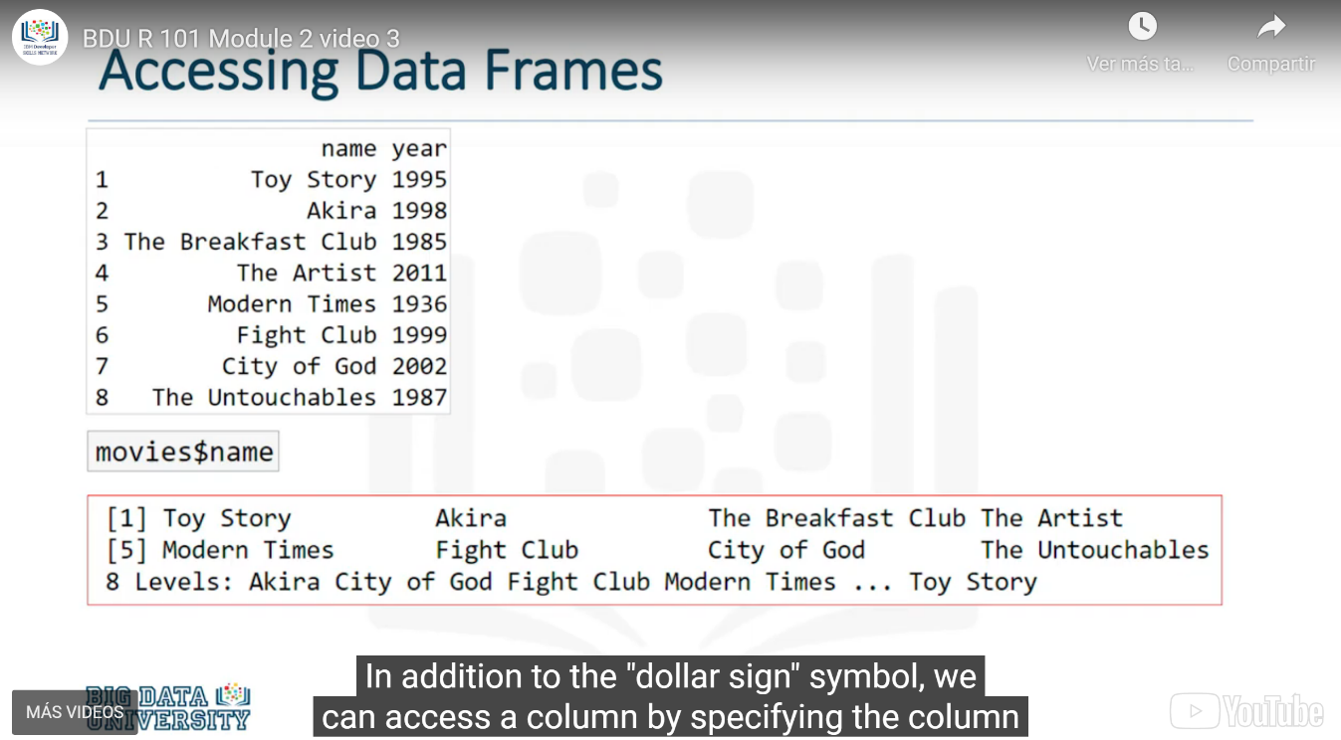

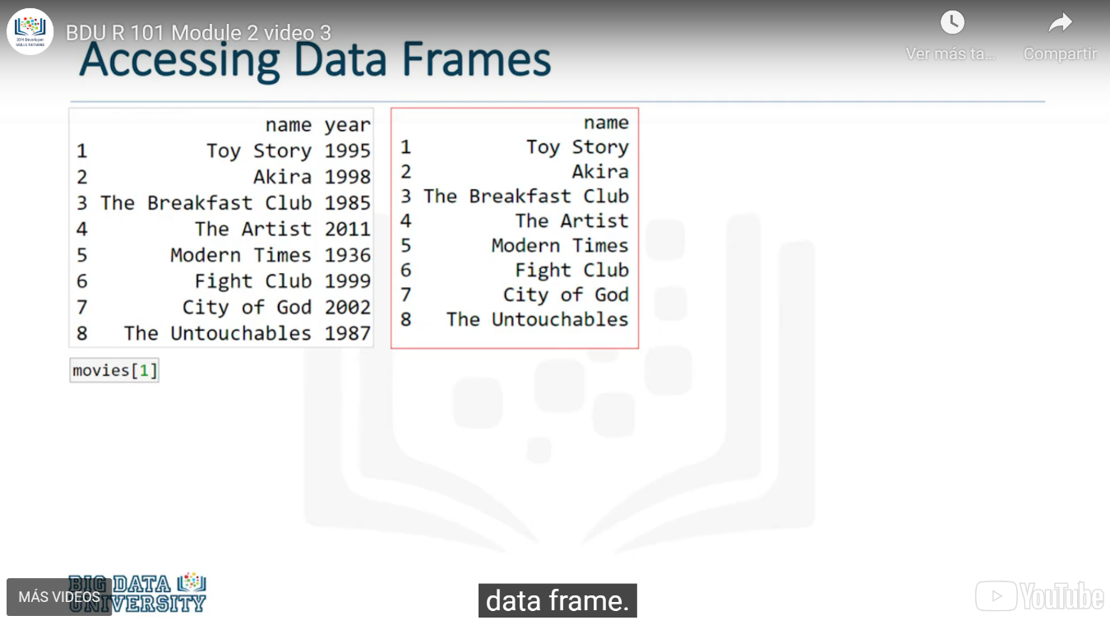

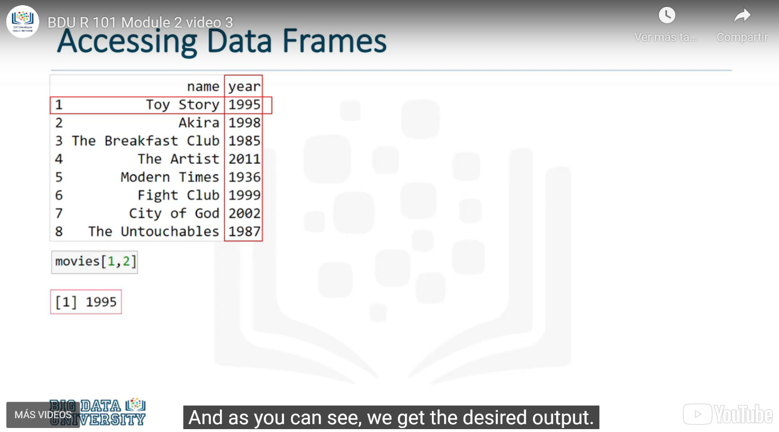

### Data Frame Structure

#### Str function

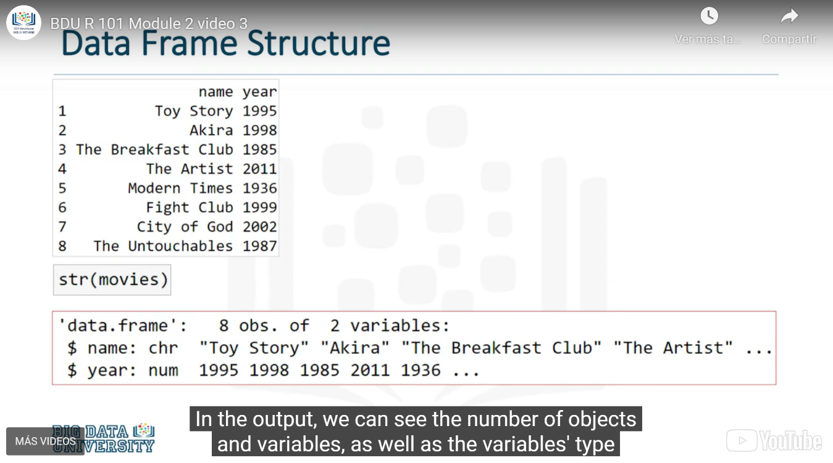

#### Head and tail function

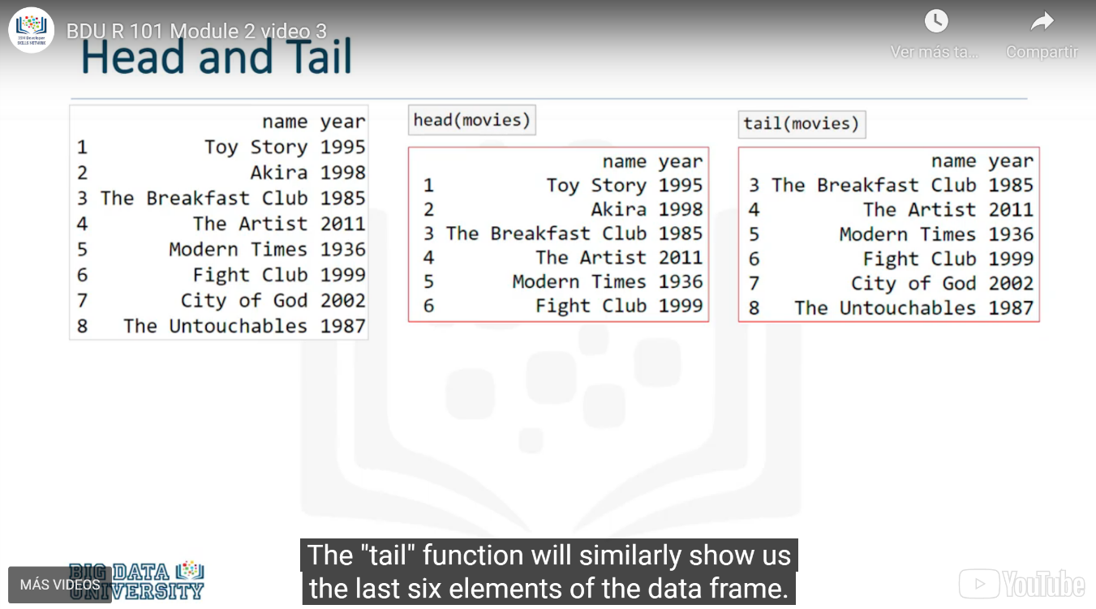

#### Insert a *new* column in a Data Frame

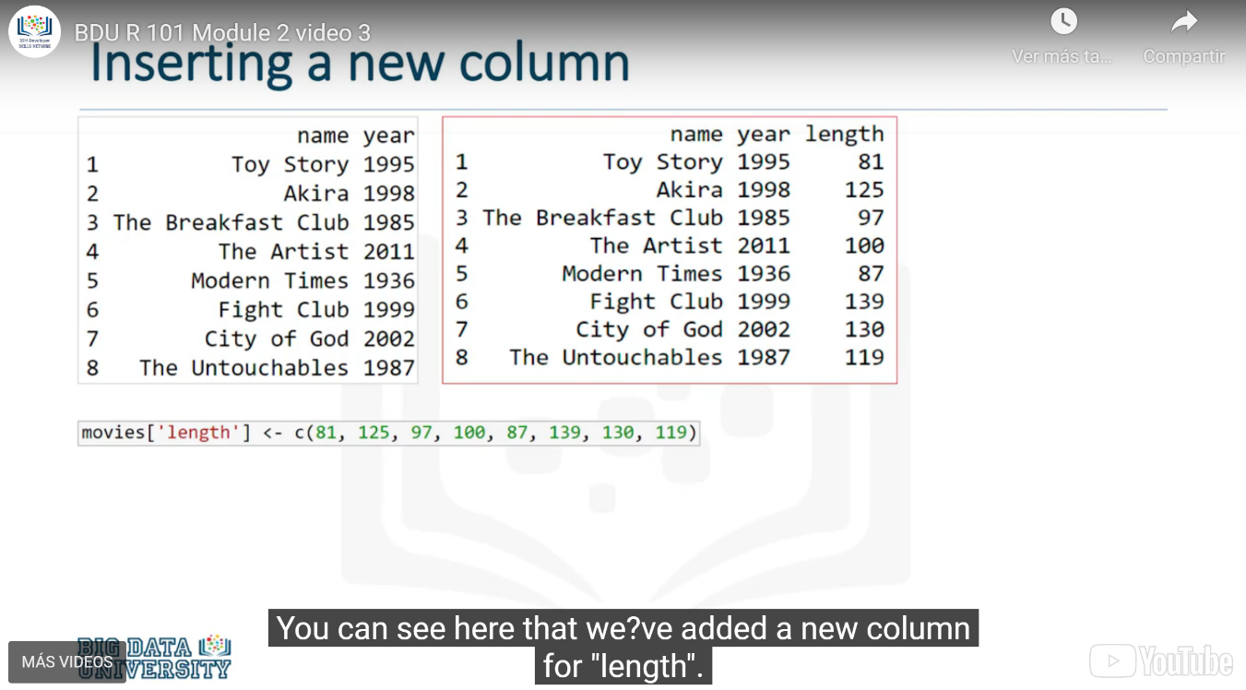

#### Insert a new row in a Data Frame

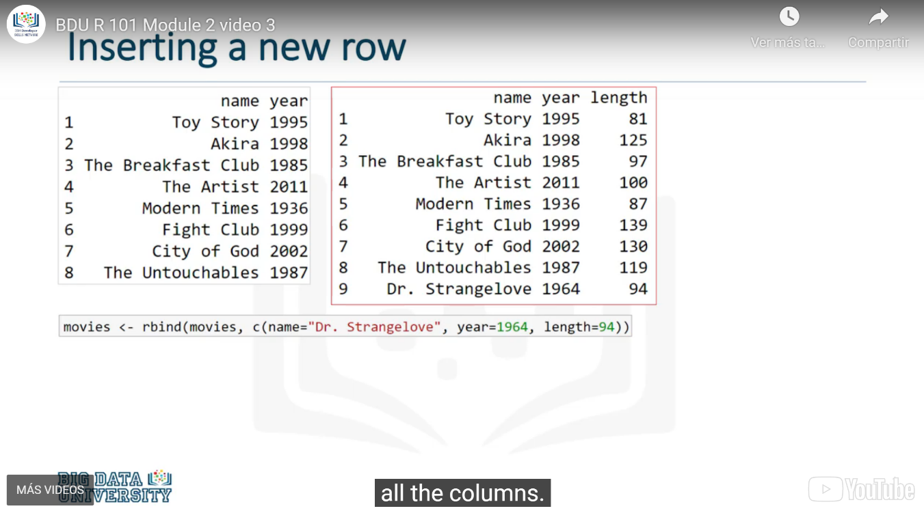

#### Deleting Rows in a Data Frame

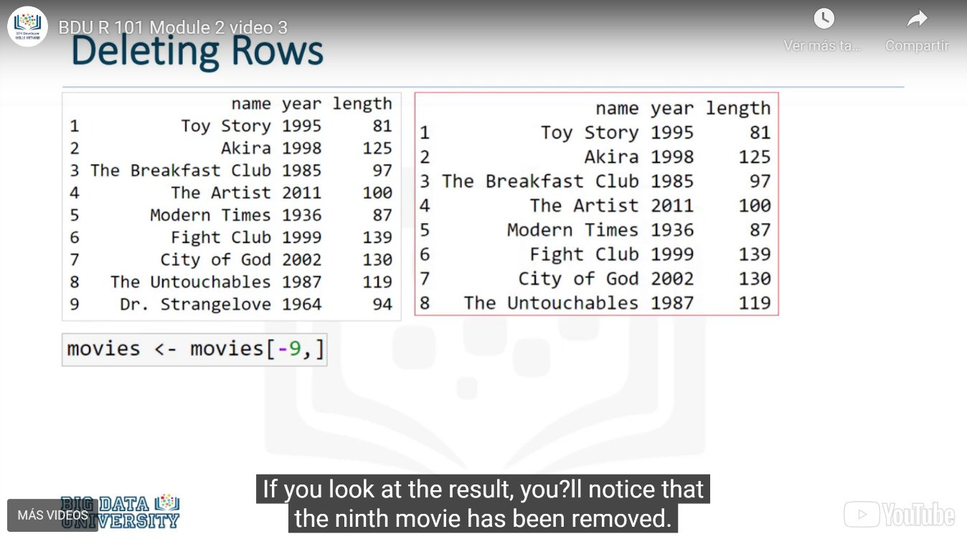

#### Deleting Columns in a Data Frame

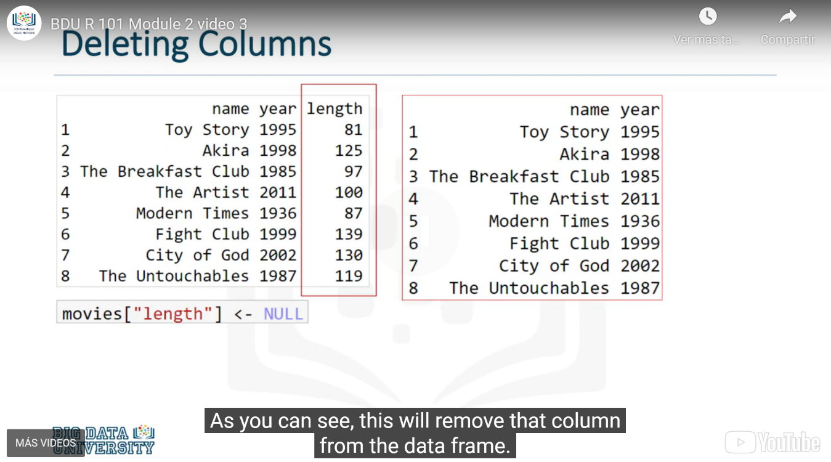

# R Programming Fundamentals

## Conditions and Loops

### Conditional Statements

Imagine that you want just the movies that were filmed after 2000. You will need to use conditional statements

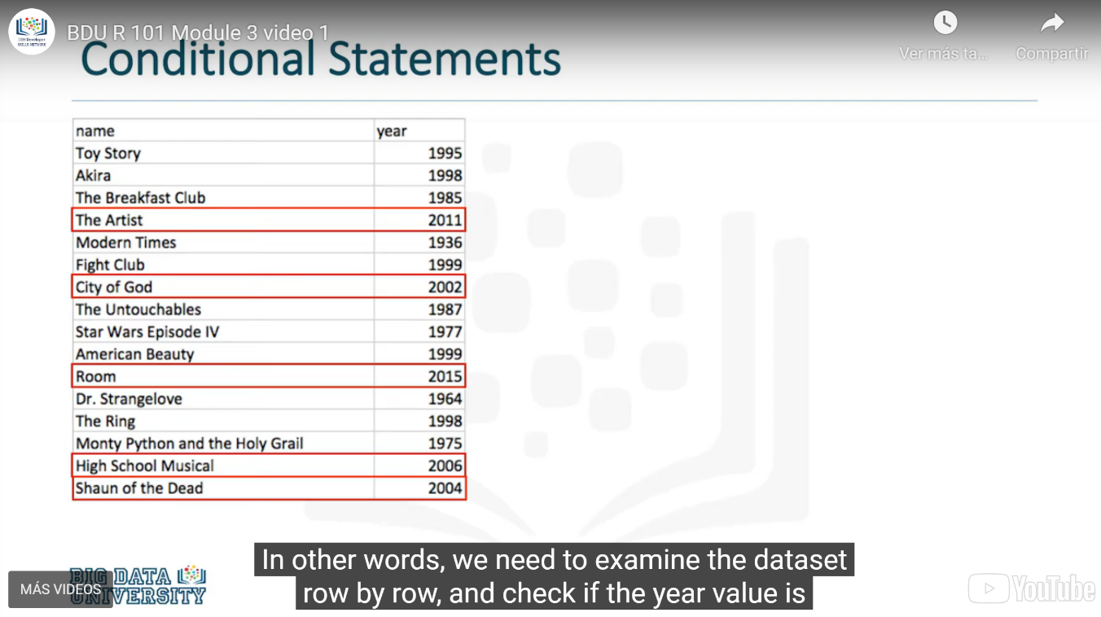

### Conditional Statement: If

**If** statements are composed of a conditional check and a block of code that is executed if the check results in **true**.

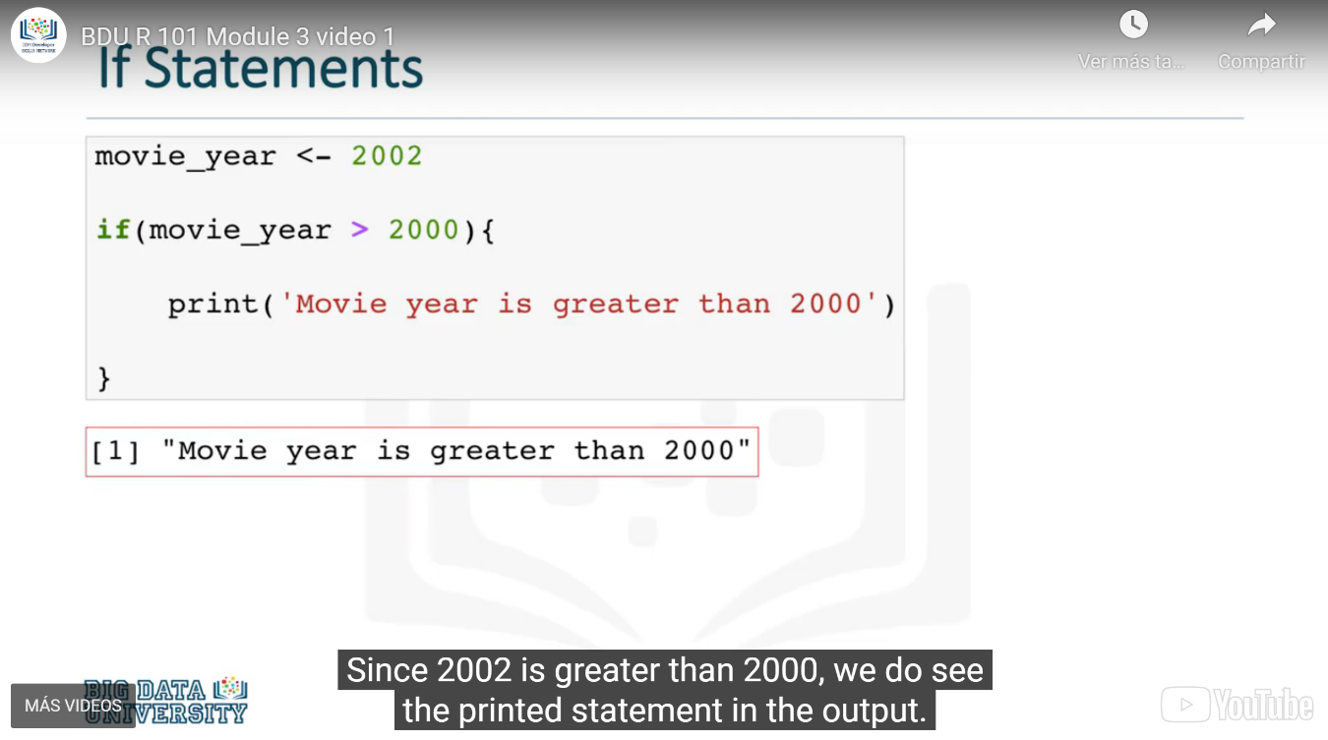

### Conditional Statement: Else

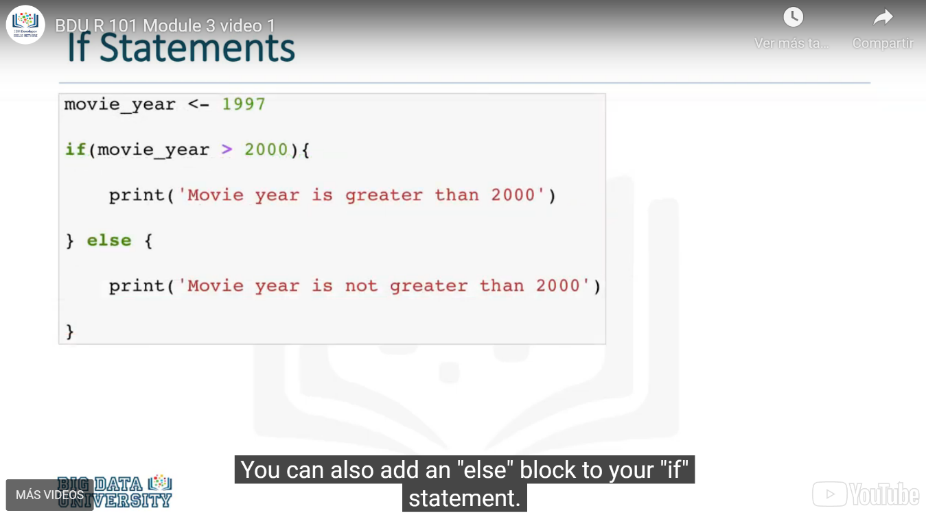

### Logical Operators

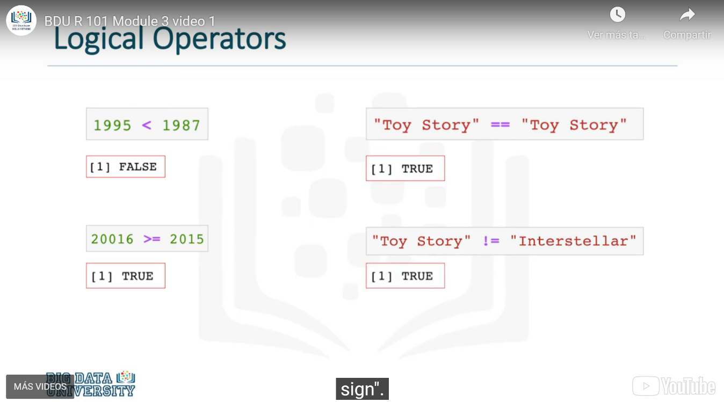

### Combining Logical Operators

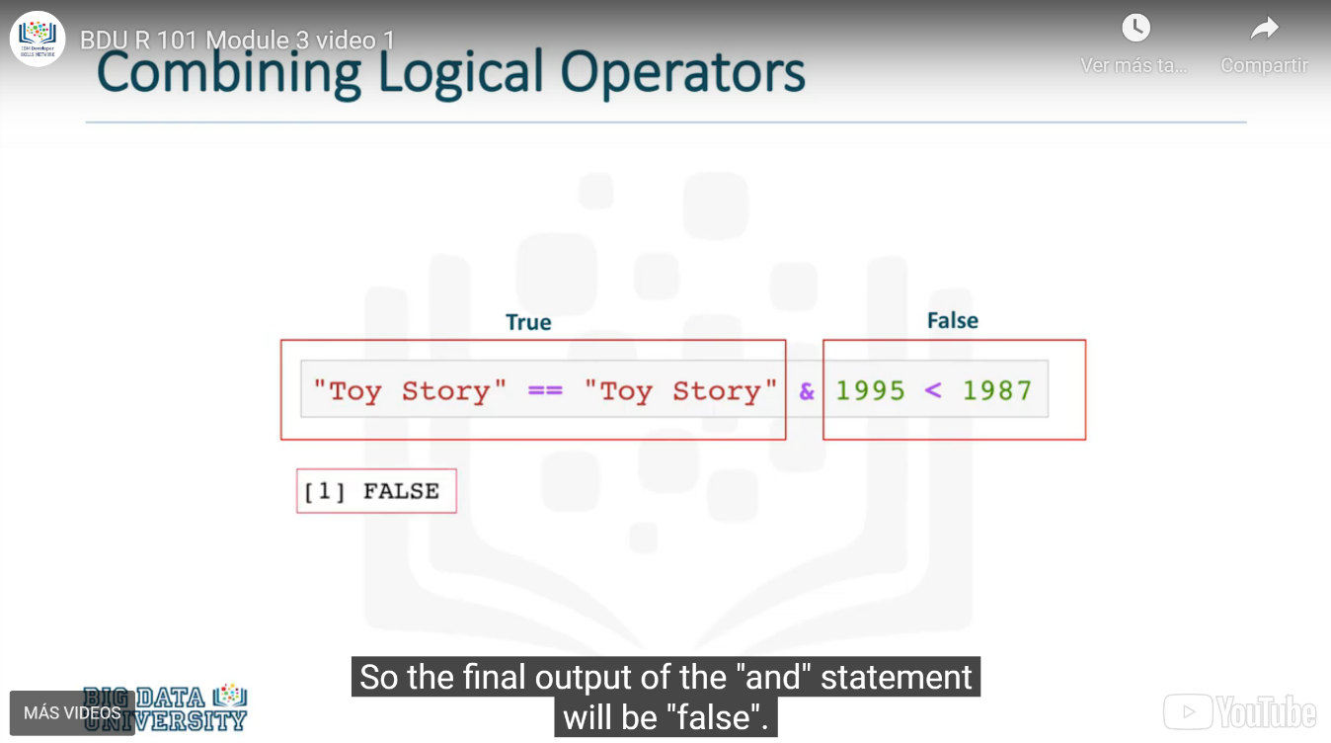

### List of comparison and logical operators

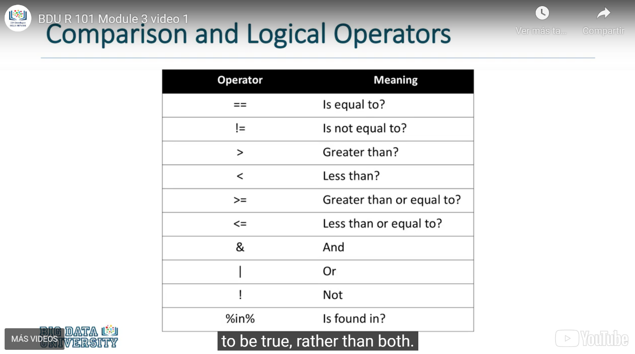

### FOR Loops

The for loop structure enables you to execute a code block once for every element in a given structure. For example, it would be like saying **execute this once for every row in my dataset**, or "execute this once for every element in this column bigger than 10". **for** loops are a very useful structure that make the processing of a large amount of data very simple.

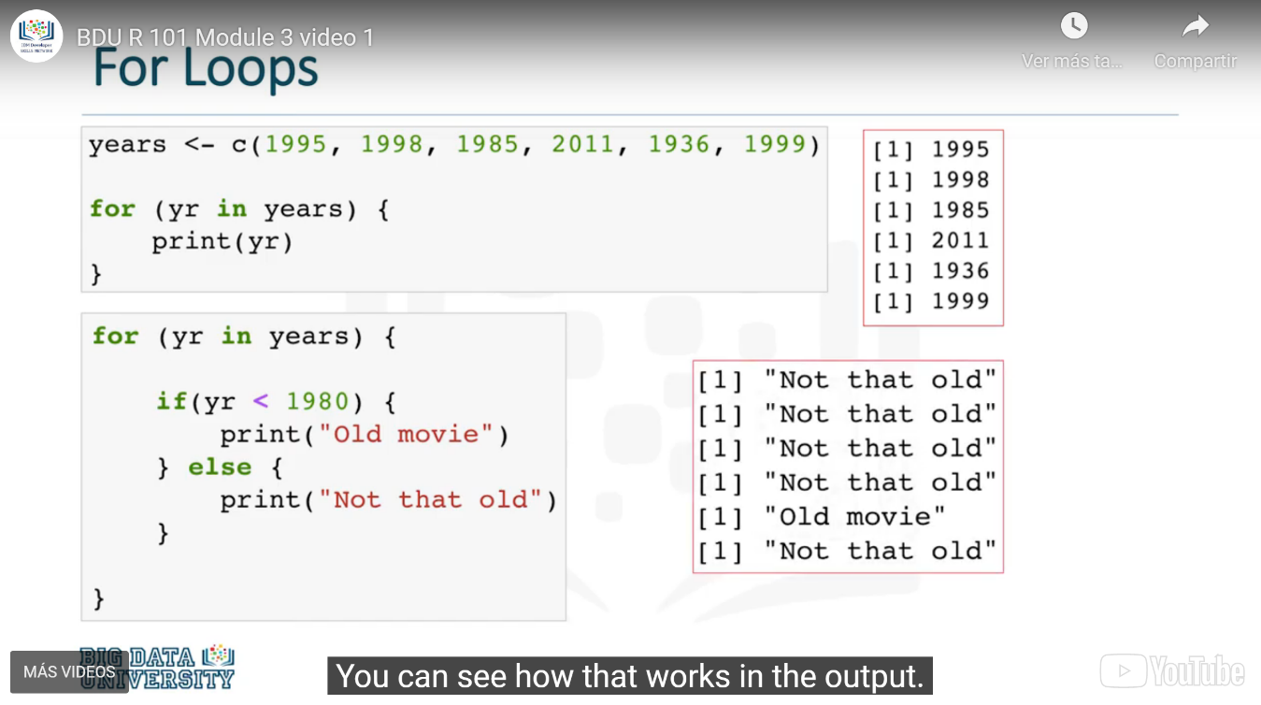

### WHILE Loops

As you can see, the for loop is useful for a controlled flow of repetition. However, what if we don't know when we want to stop the loop? What if we want to keep executing a code block until a certain threshold has been reached, or maybe when a logical expression finally results in an expected fashion?

The while loop exists as a tool for repeated execution based on a condition. The code block will keep being executed until the given logical condition returns a False boolean value.

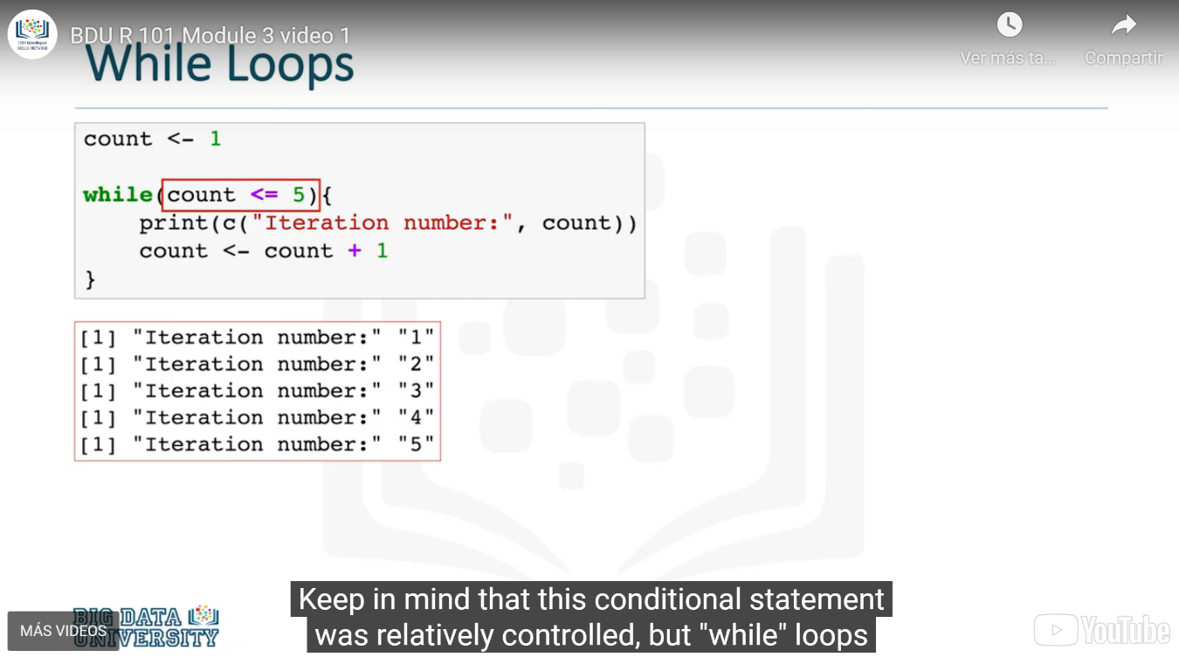

## Functions in R

A function is a re-usable block of code which performs operations specified in the function.

There are two types of functions :

* **Pre-defined functions**
* **User defined functions**

**Pre-defined** functions are those that are already defined for you, whether it's in R or within a package. For example, **sum()** is a pre-defined function that returns the sum of its numeric inputs.

**User-defined** functions are custom functions created and defined by the user. For example, you can create a custom function to print **Hello World**.

### Predefined functions: mean( ) sort( )

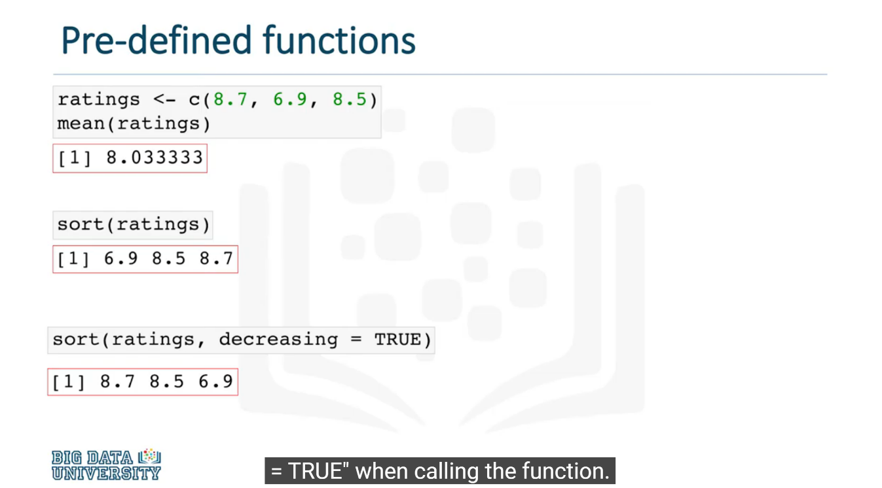

### User-defined functions

Tu mismo puedes desarrollar tu propia función y ponerle un nombre para que la función cumpla con las instrucciones que tu le indiques

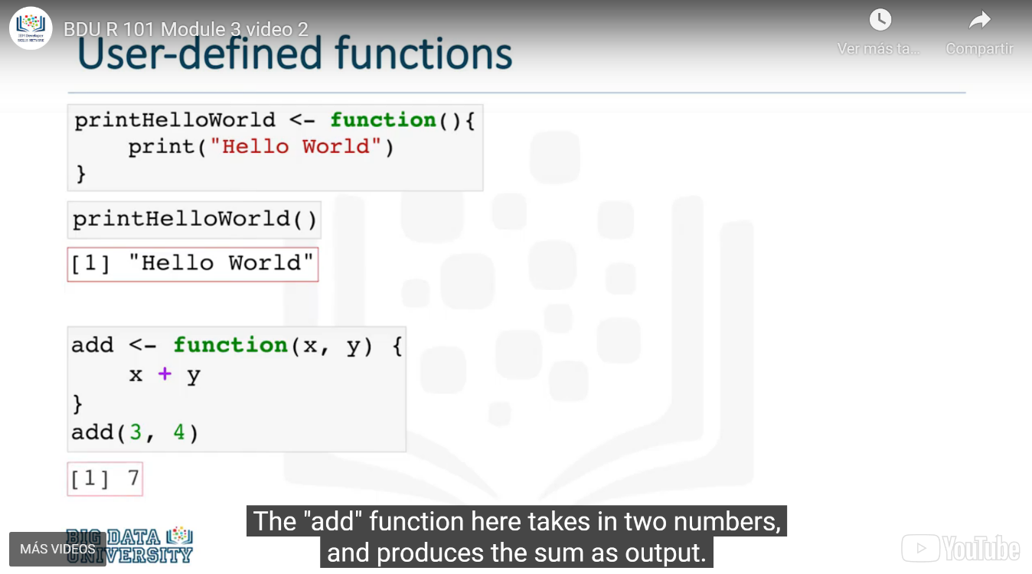

### Return Fuction.

El comando “return” se utiliza para obtener explícitamente un valor de una función.

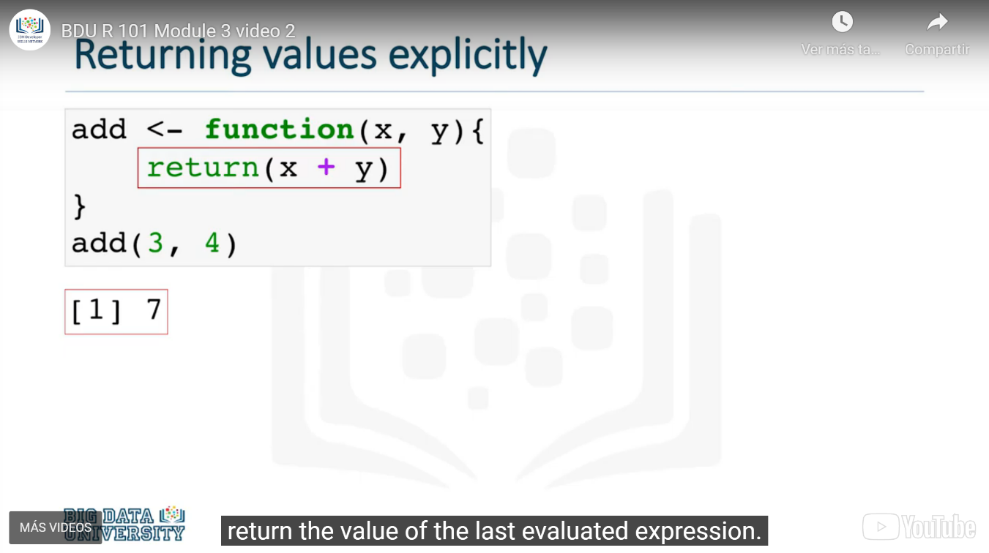

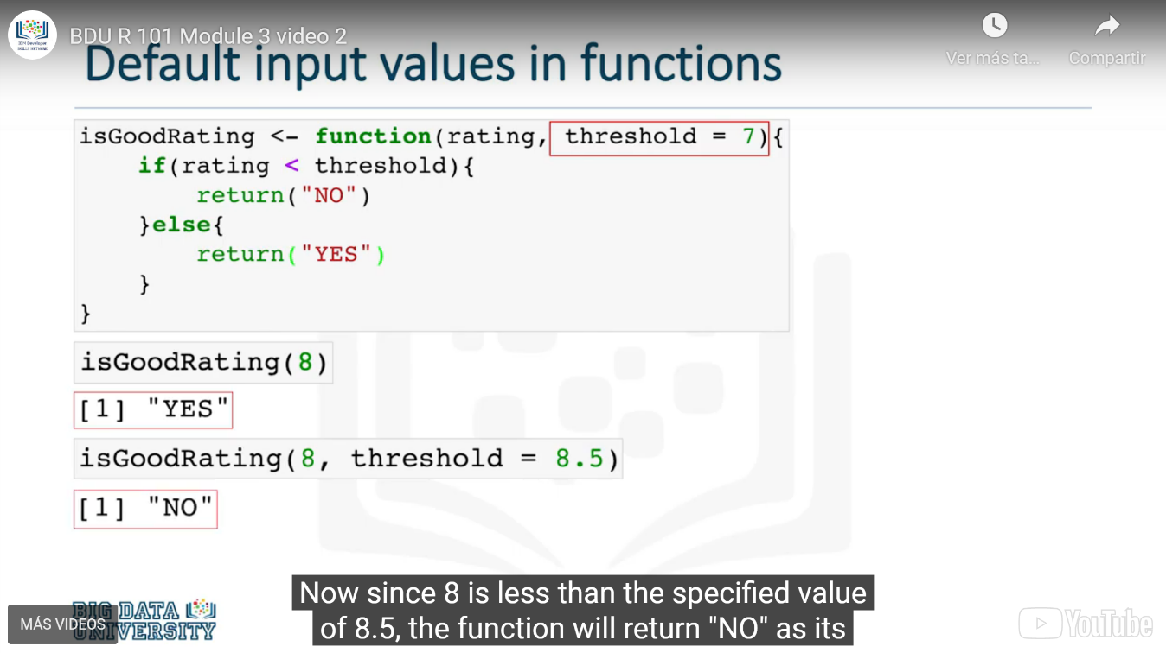

### If & Else Functions

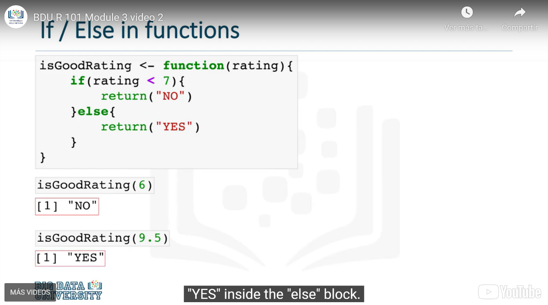

### Using functions within functions

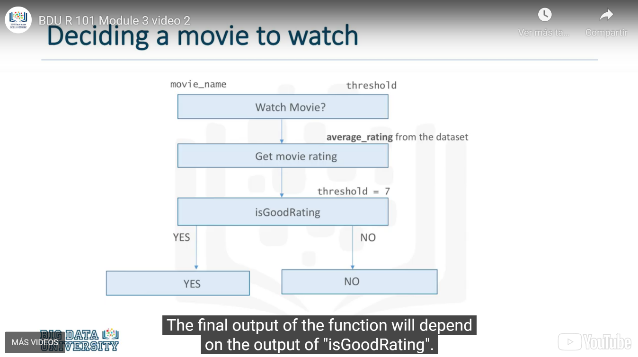

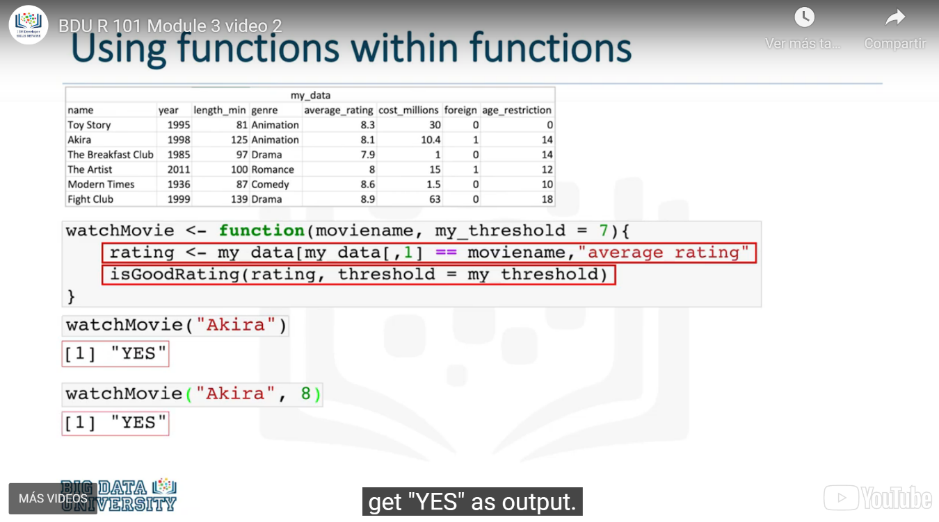

### Global and Local values

El comando <<-— se utiliza para mostrar que la variable y es externa a la función que se está creando. Es decir, y se convierte en una variable global, no una variable local que solo puede ser operada si se ejecuta la función que la creó.

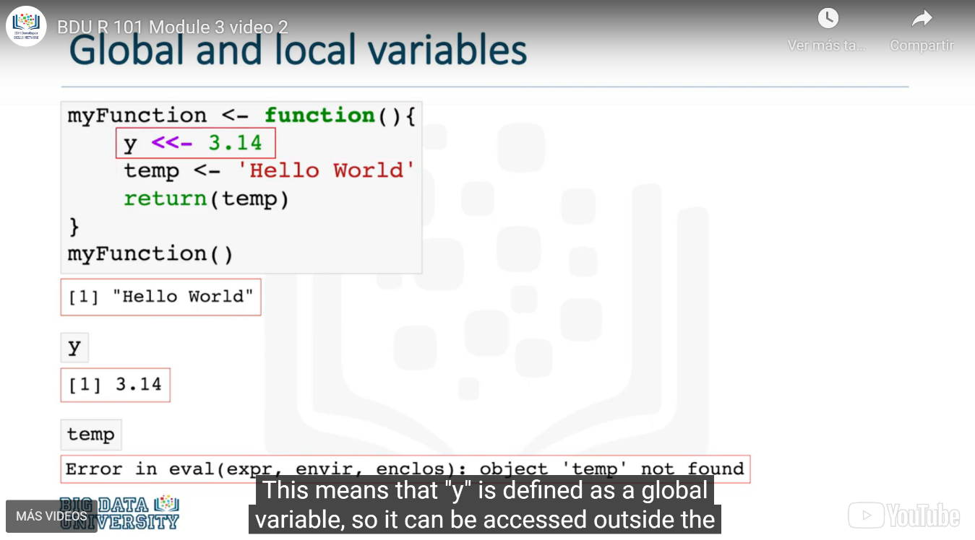

## Objects and Classes

### Objects in R: Numeric / Character / Logical / Integer

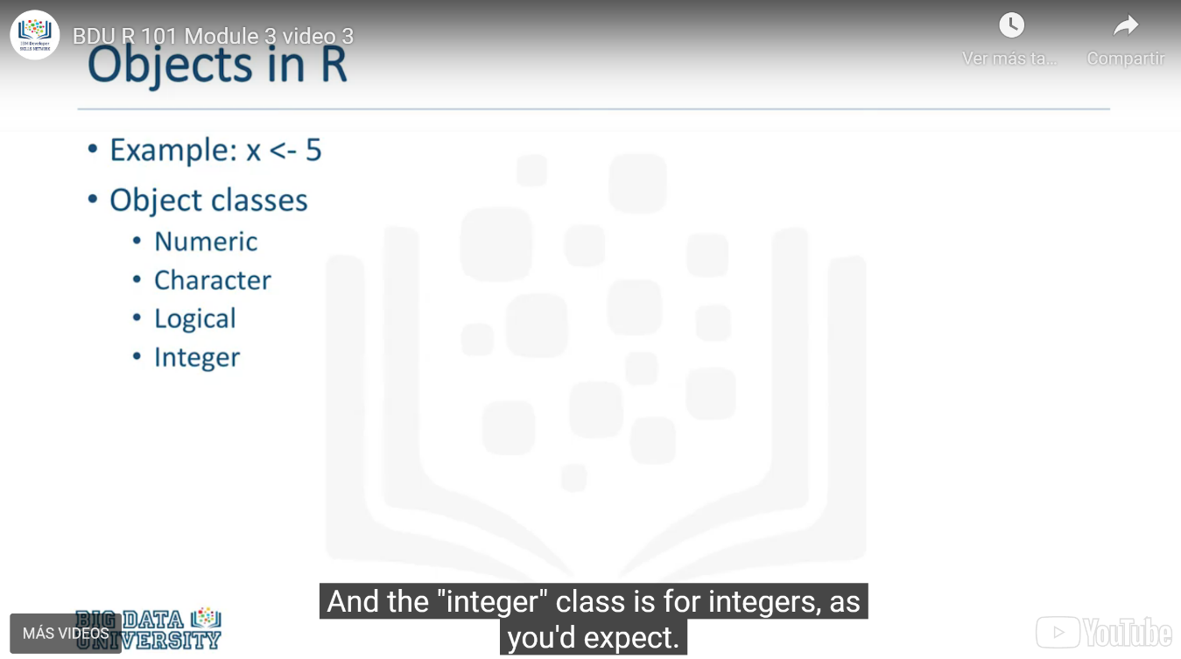

### Objects: Numeric

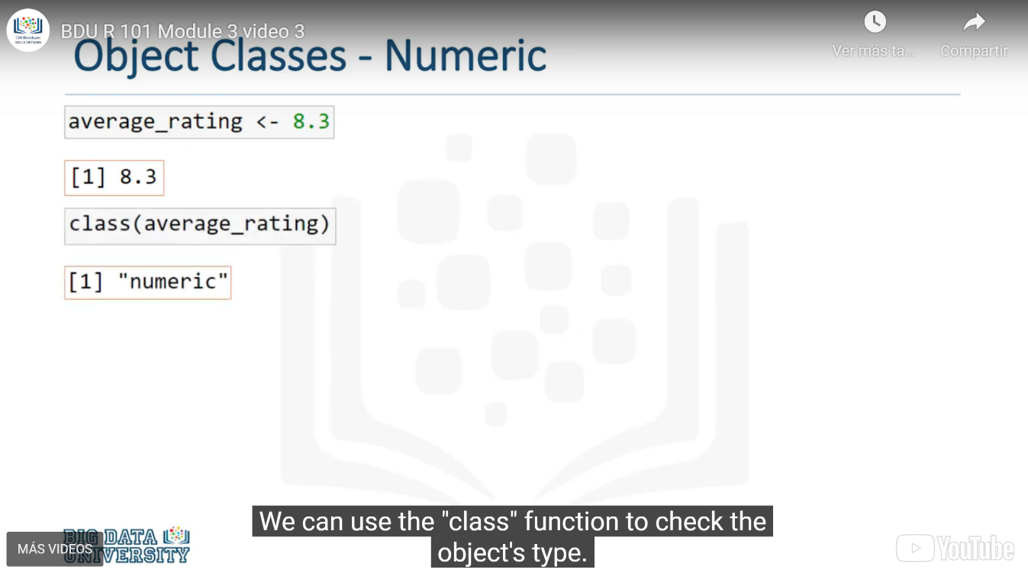

### Objects: Character “String”

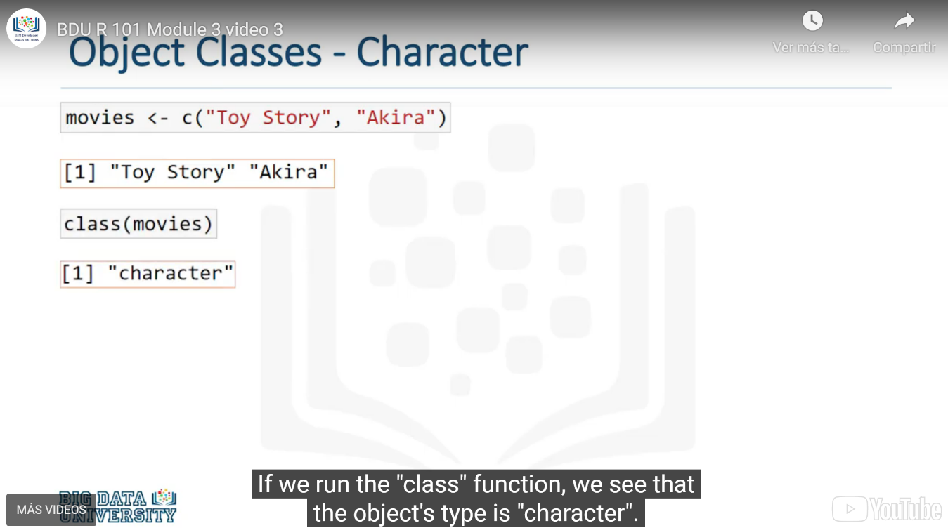

### Objects: Logical (TRUE, FALSE)

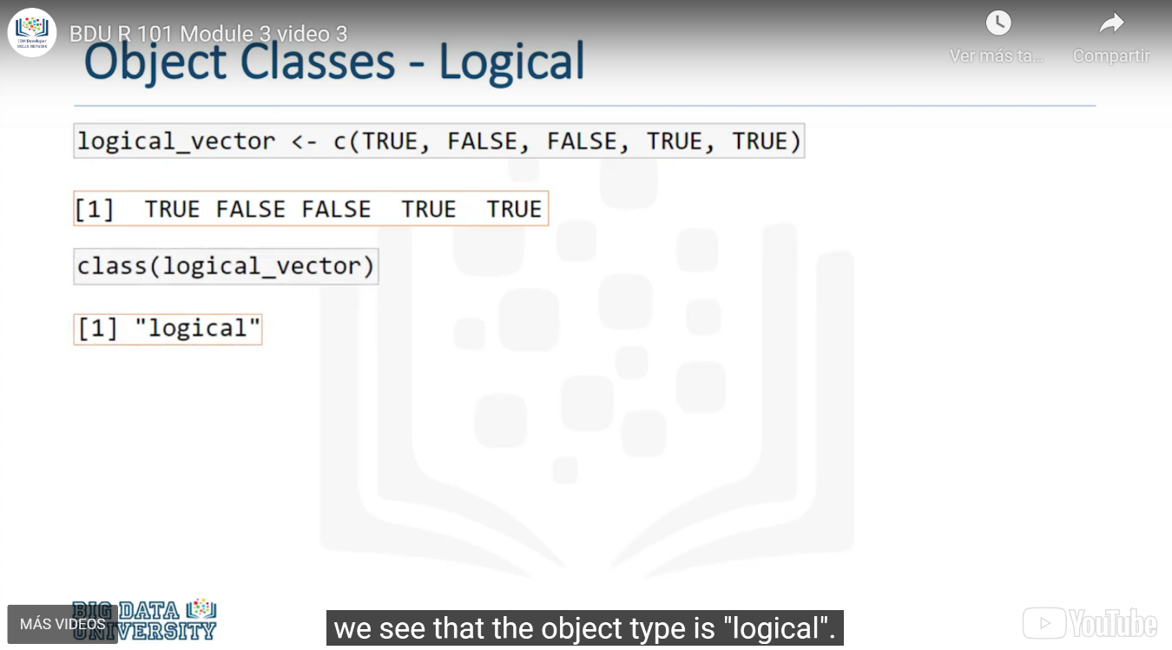

### Objects: Integer

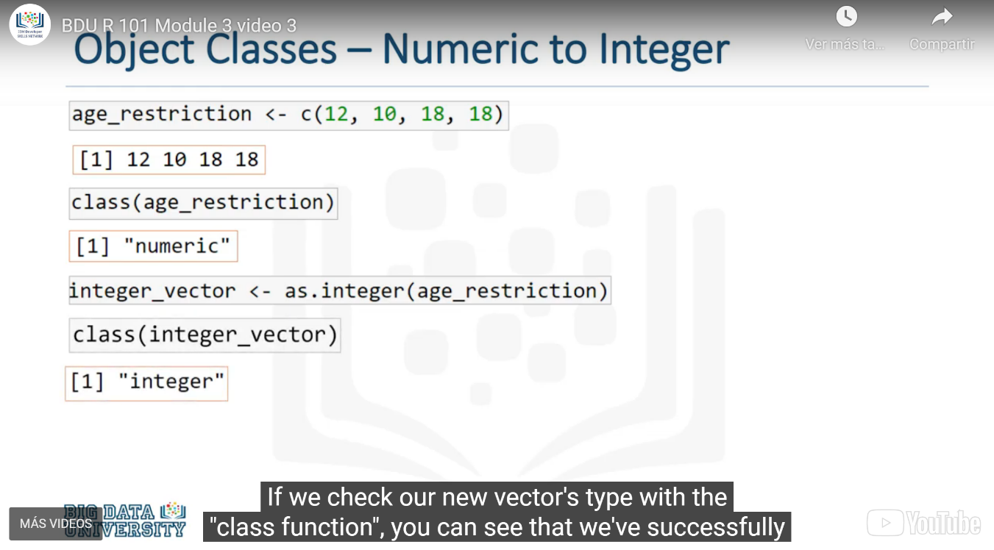

### Converting Objects: From Numeric to Character

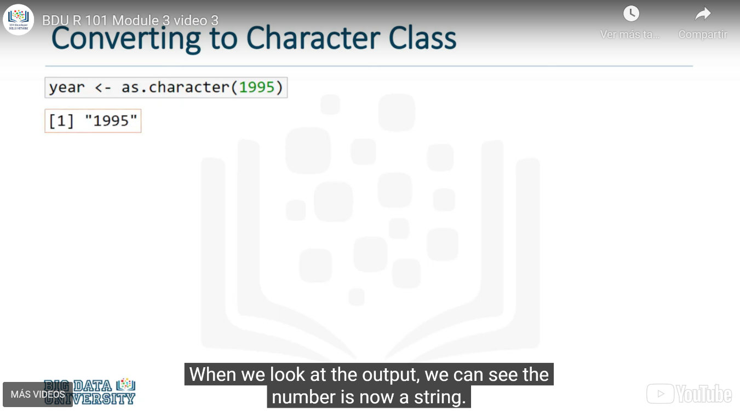

### Combining numbers and characters in a vector

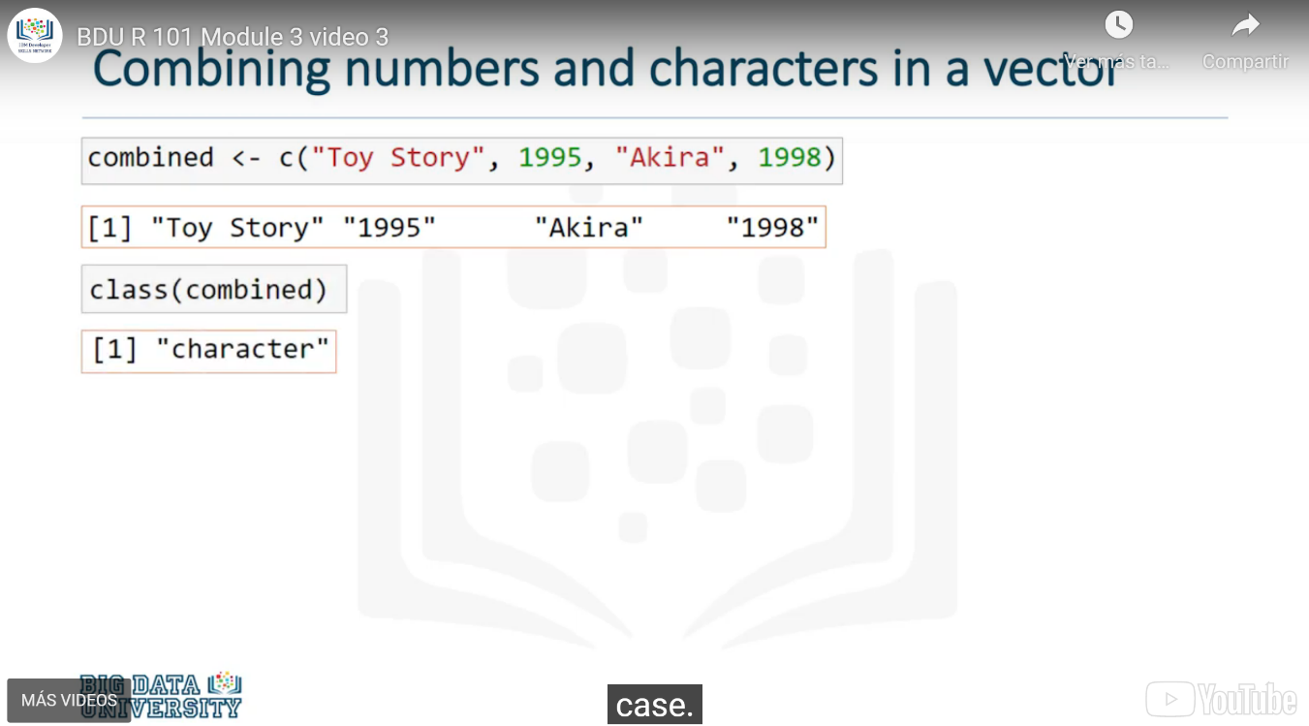

## Debugging

The process of finding the source of a programming error and fixing them, is known as **debugging**.

### Errors in R

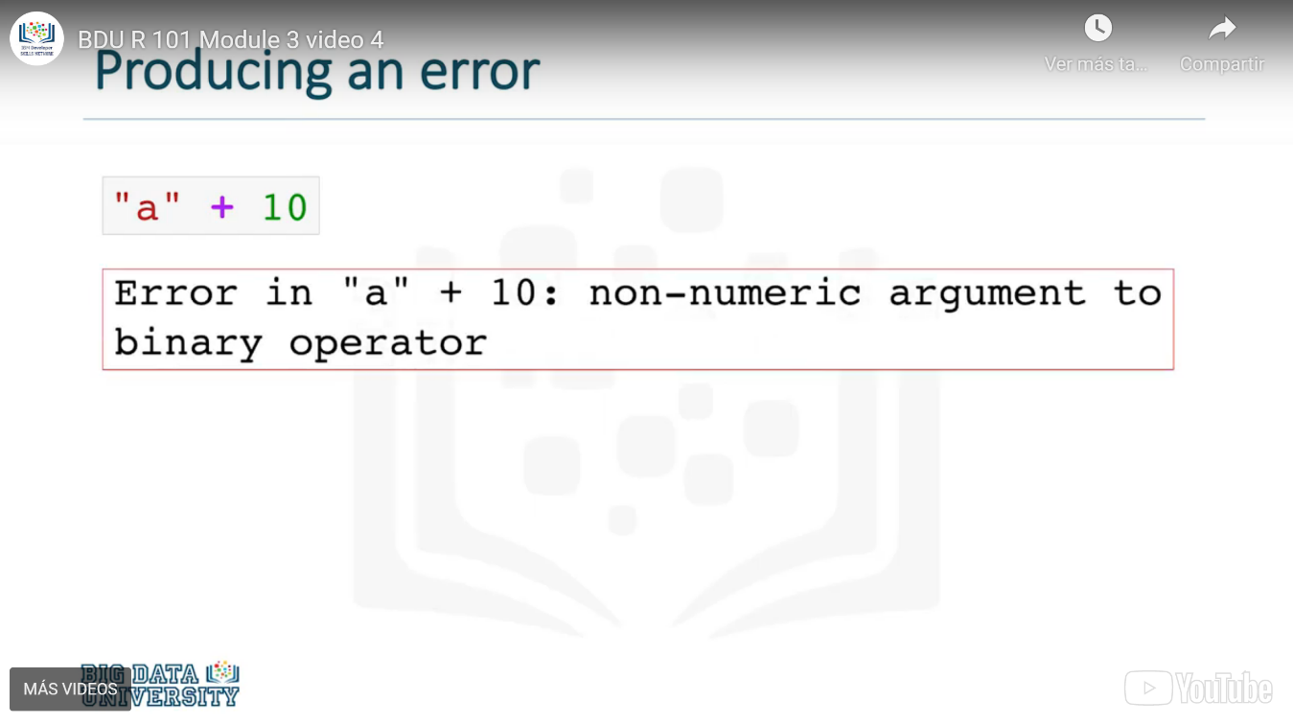

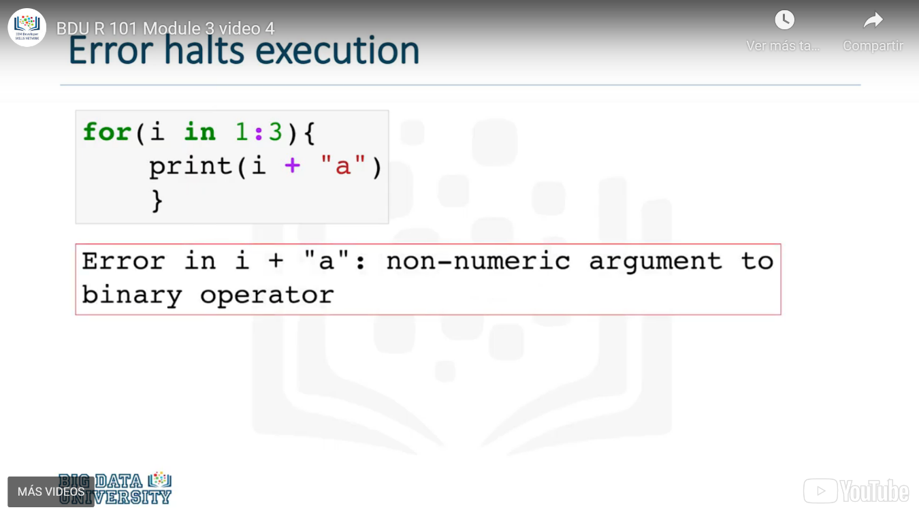

### Debugging: Function tryCatch

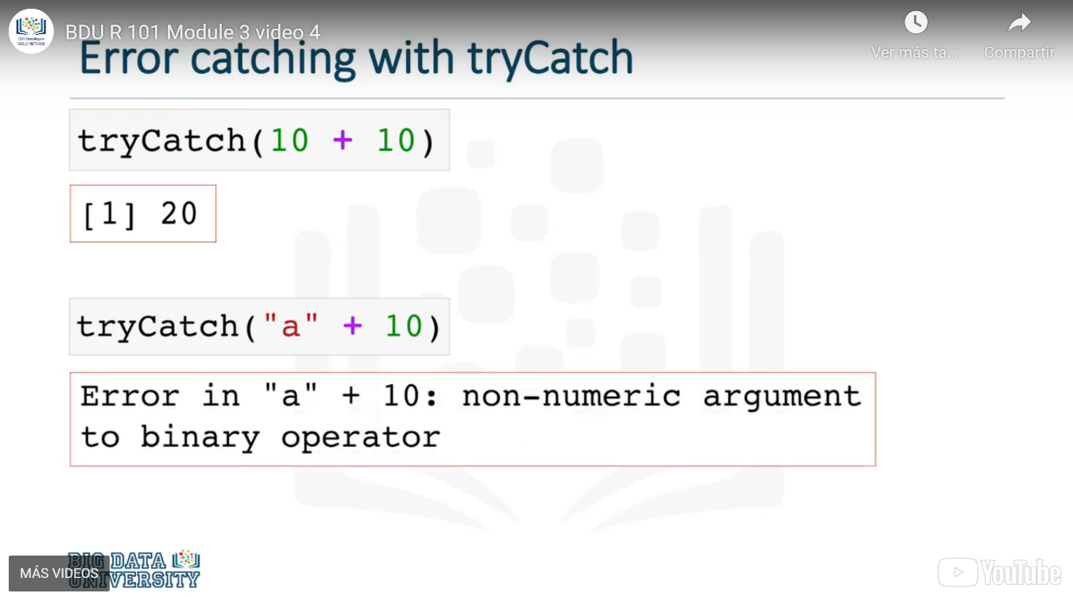

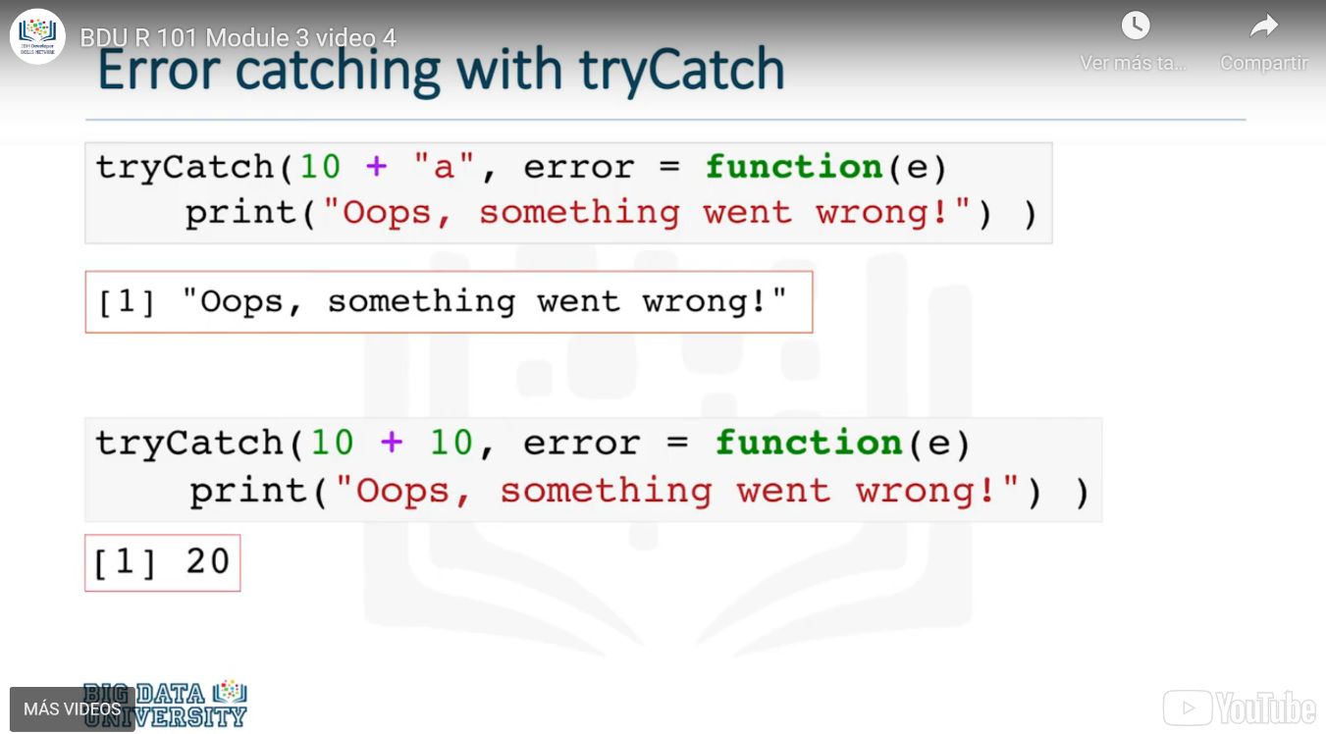

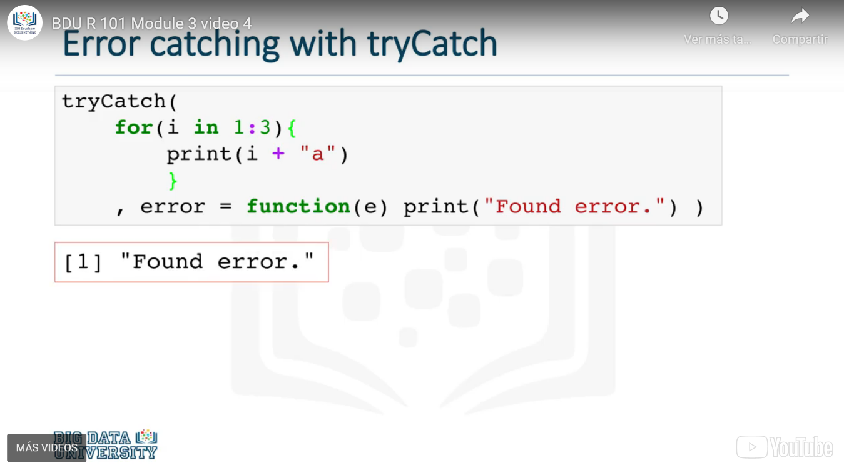

### Warning messages

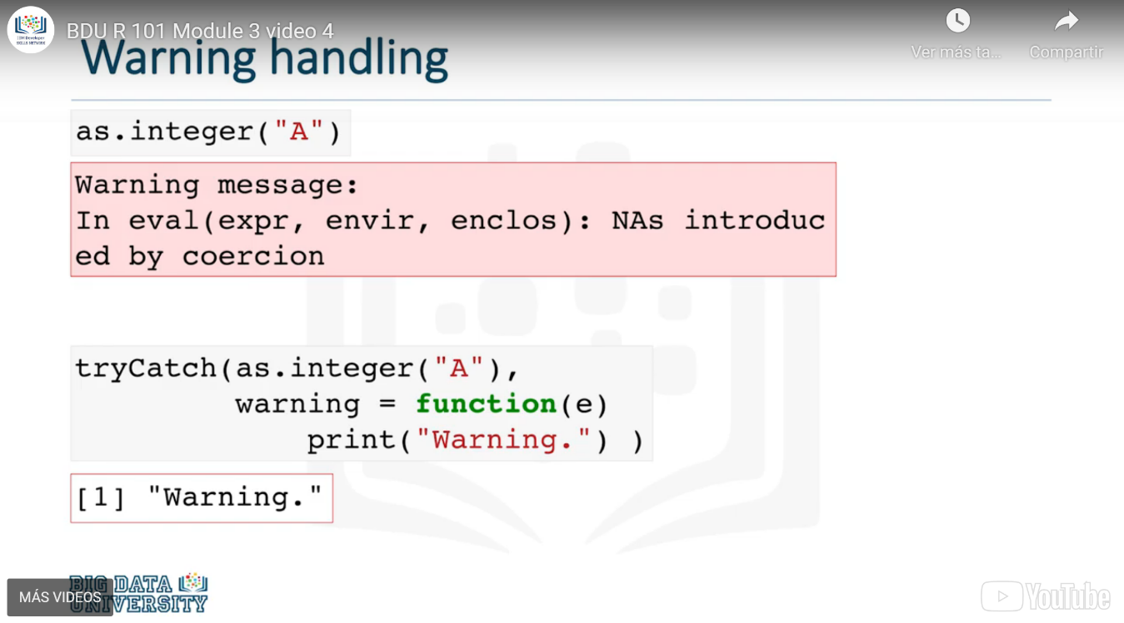

# Working with data in R

## Reading CSV, Excel and Built-in Databases

### Reading CSV with read.csv

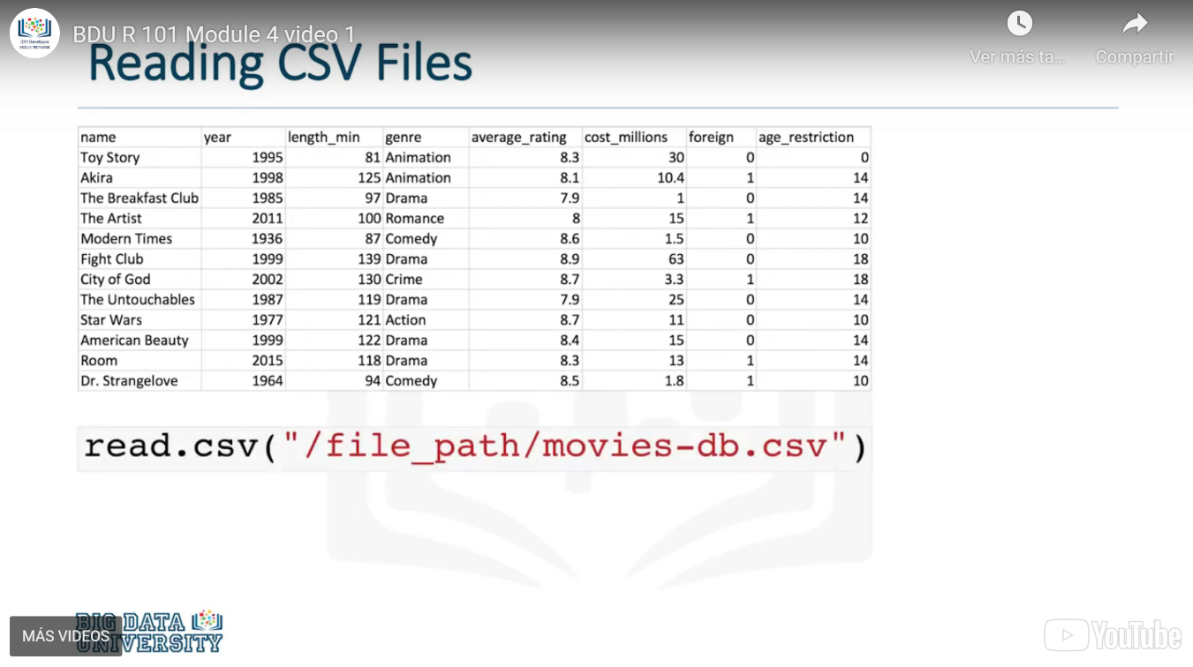

### Reading excel files with readxl

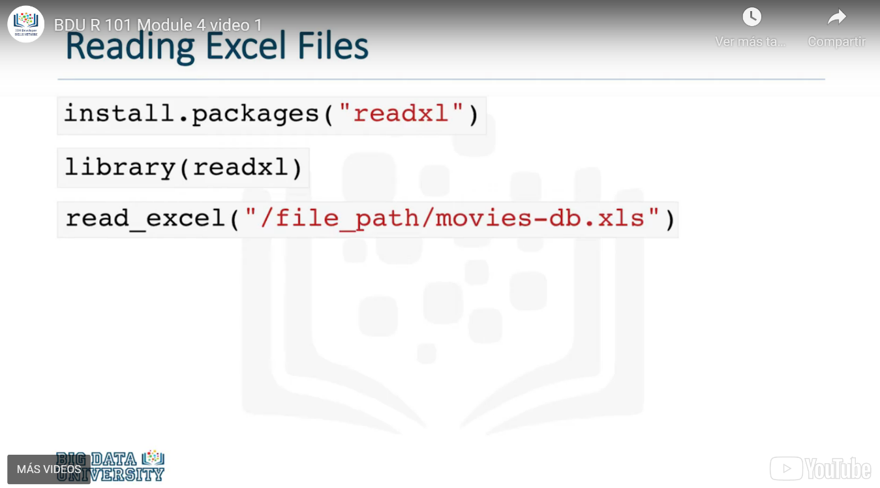

### Accessing Data from a Dataset

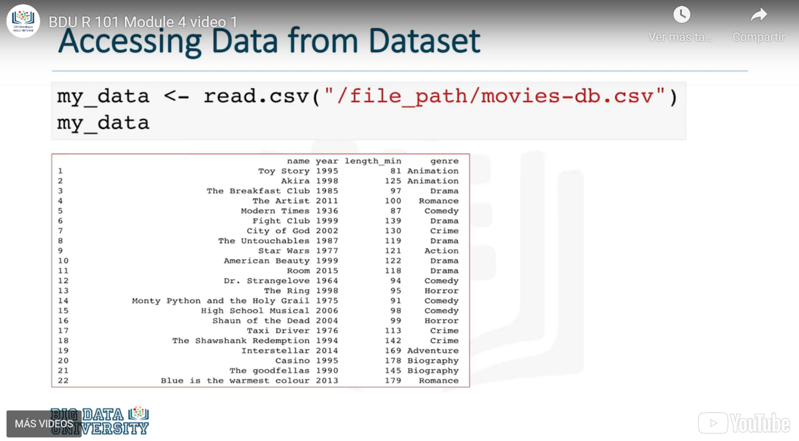

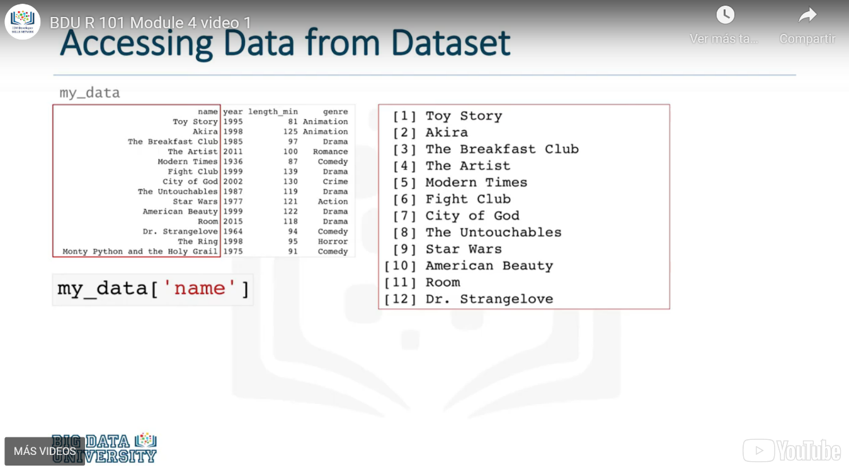

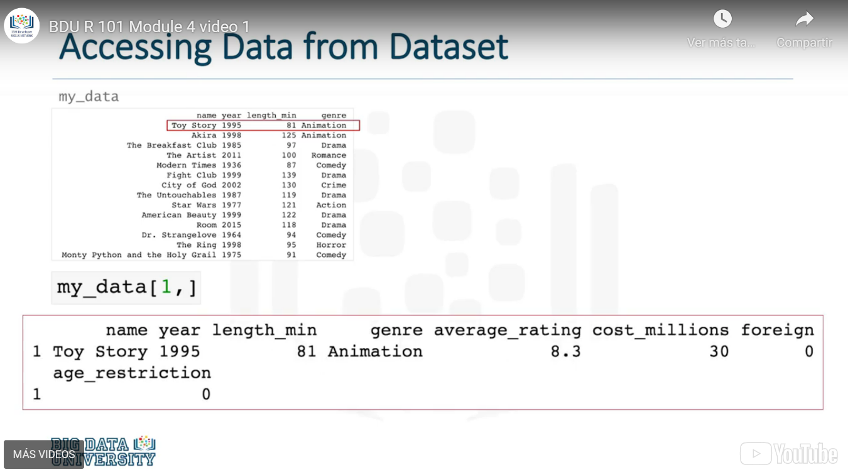

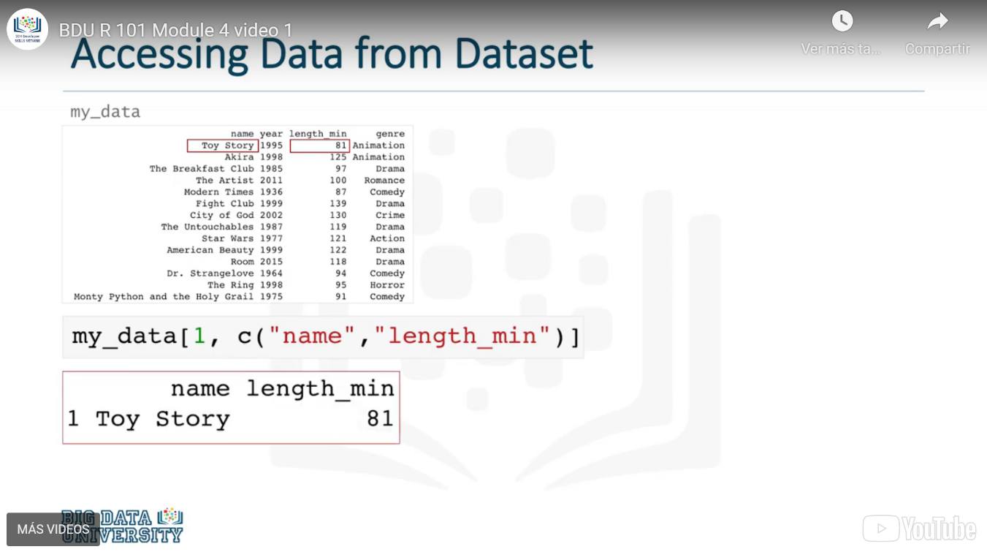

### Accessing Built-in Datasets

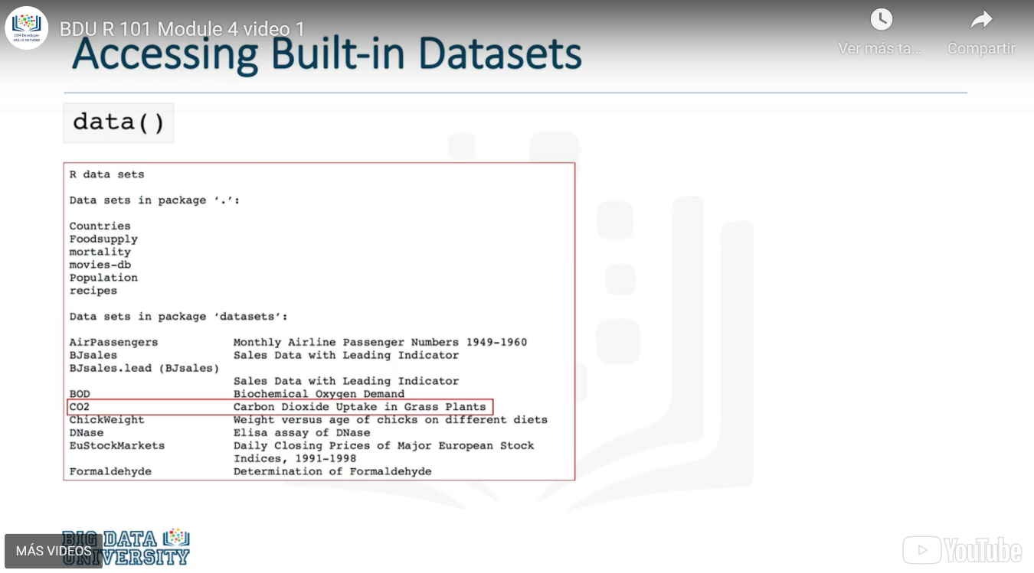

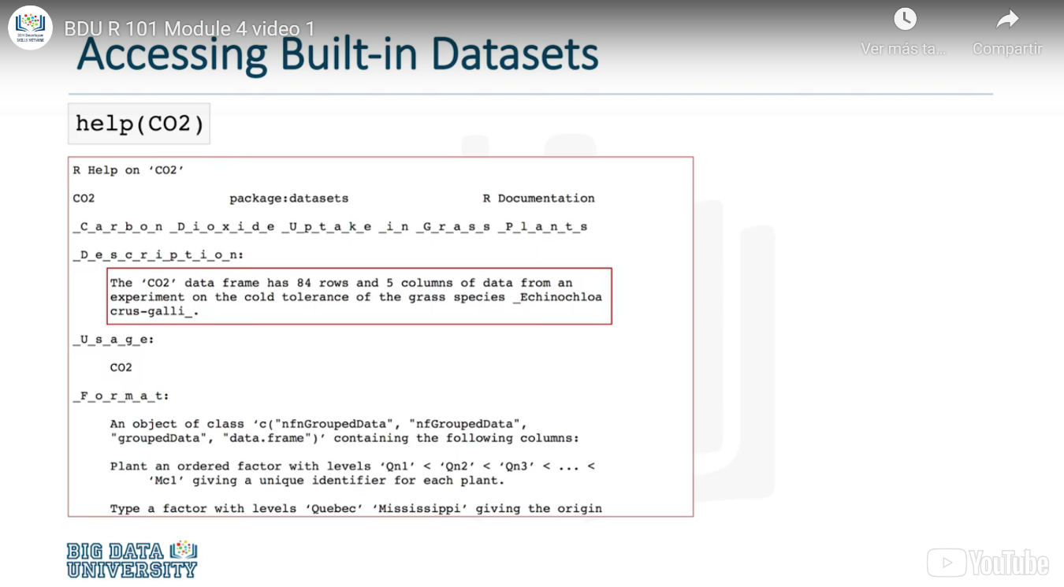

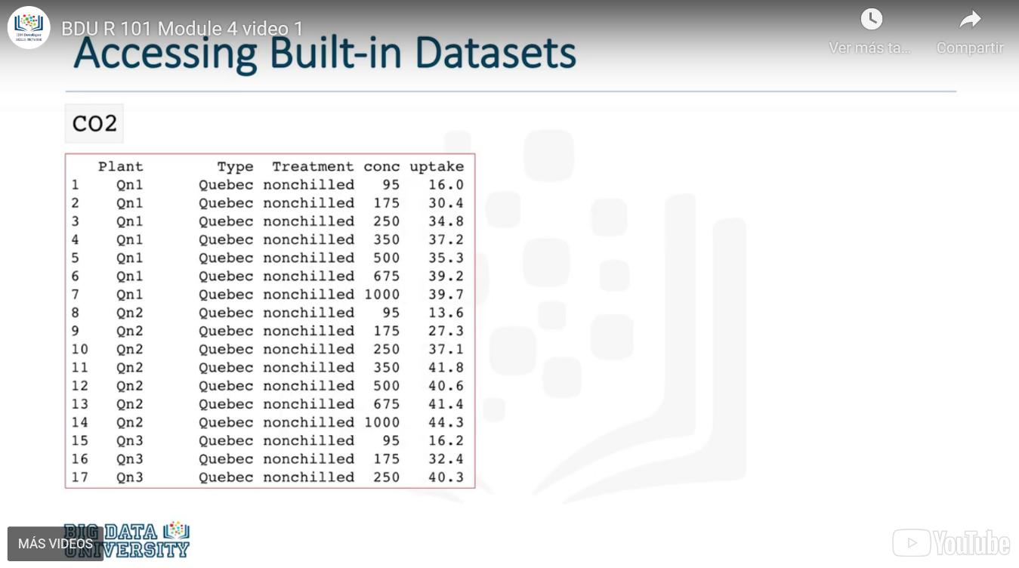

## Reading Text files (.txt) in R

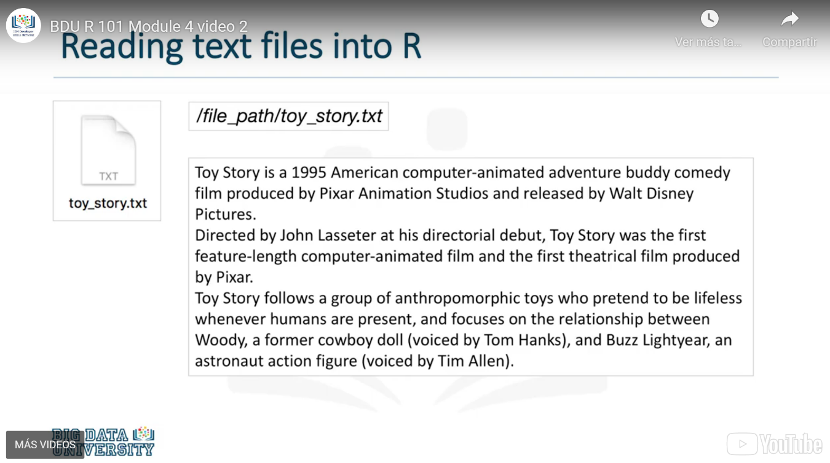

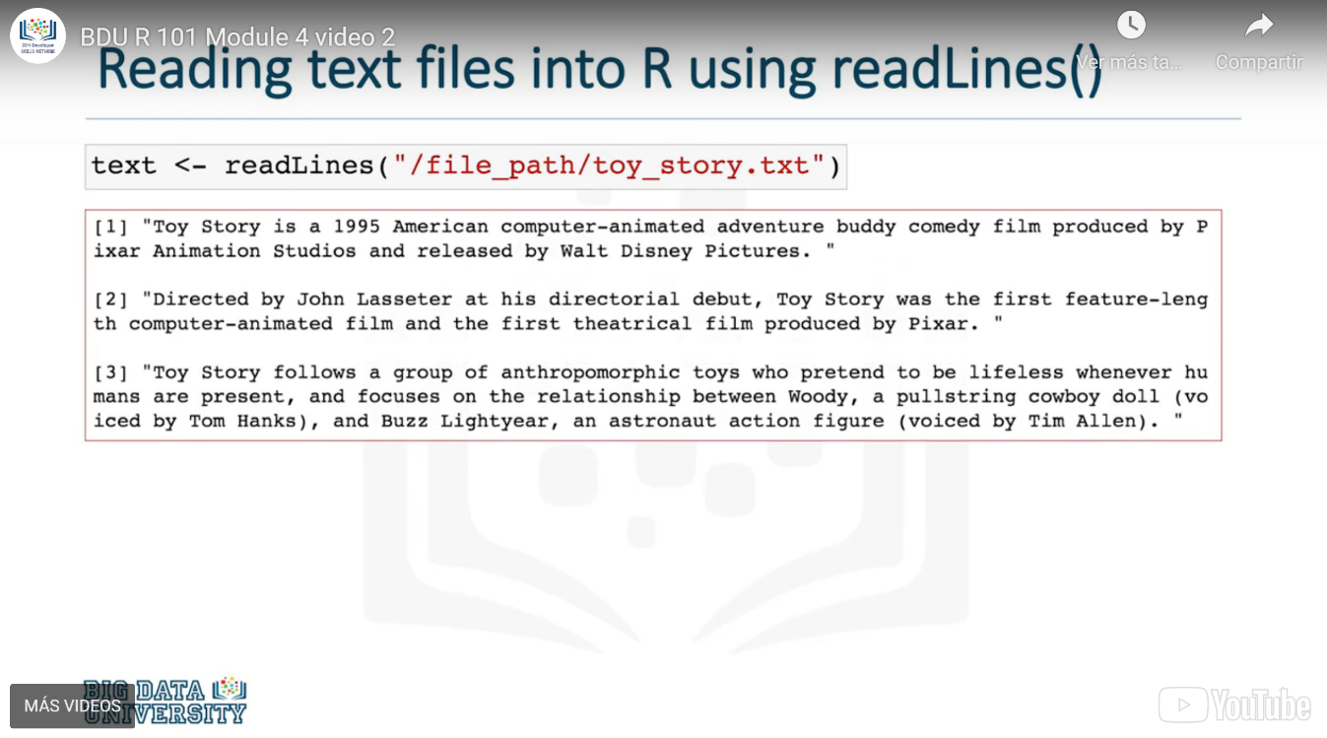

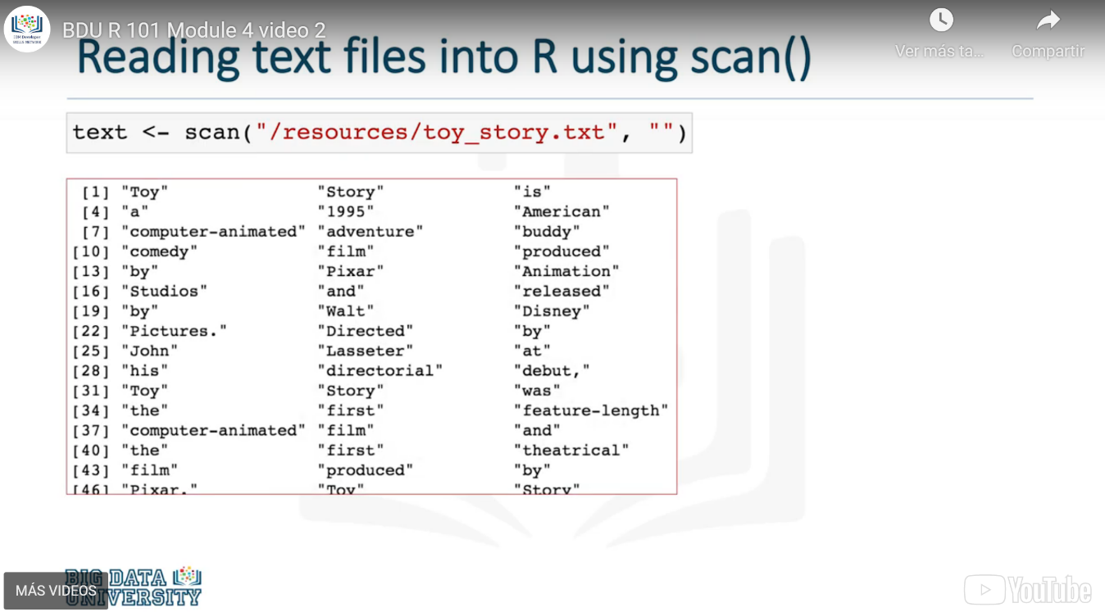

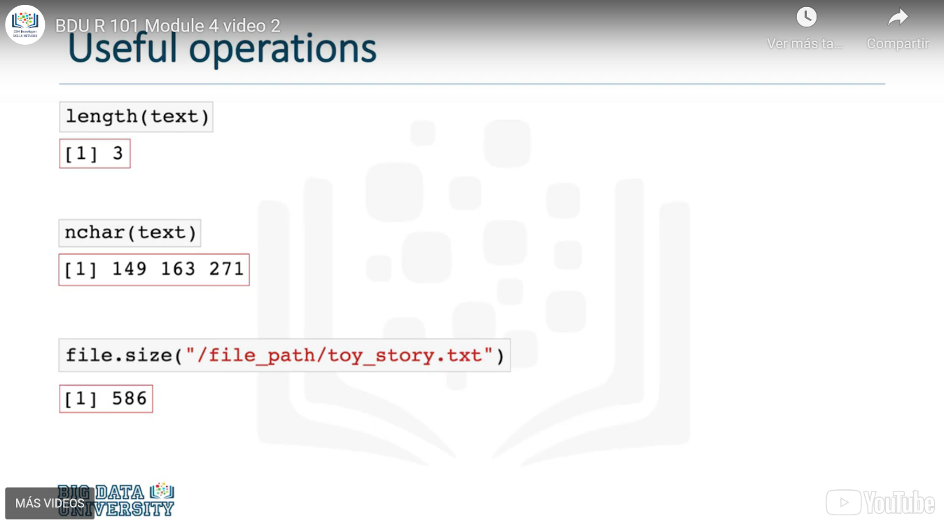

## Writing and Saving to files in R

### Exporting as a text file

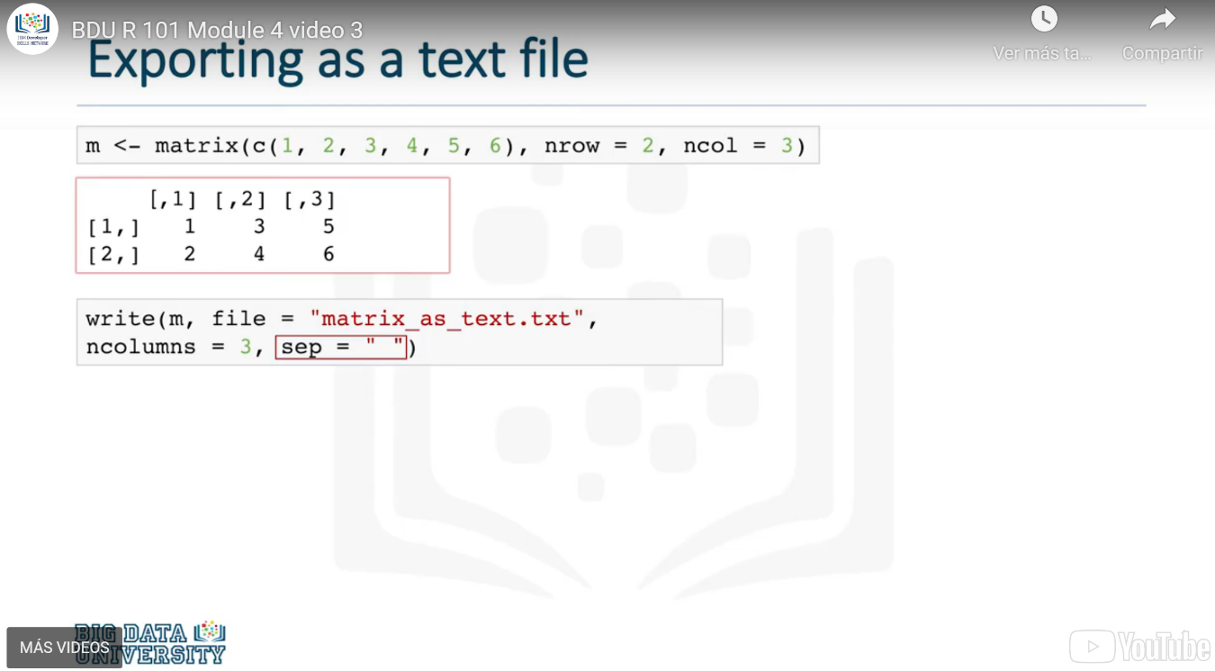

### Exporting as a CVS file

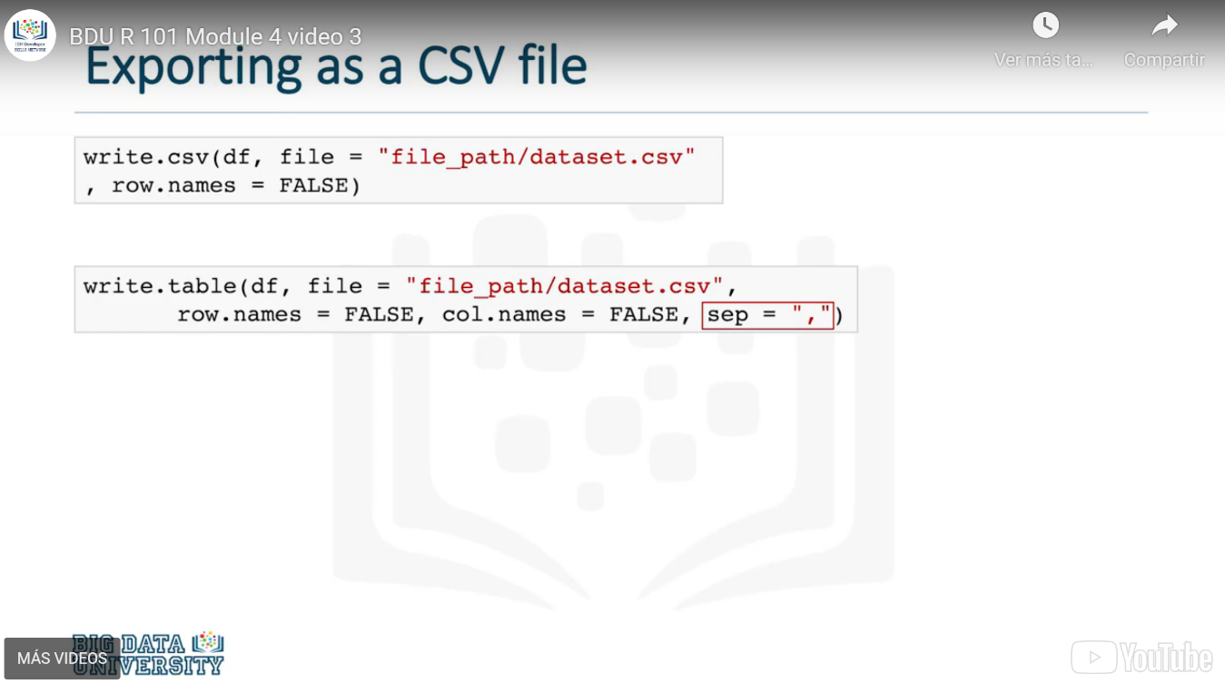

### Exporting as an excel file

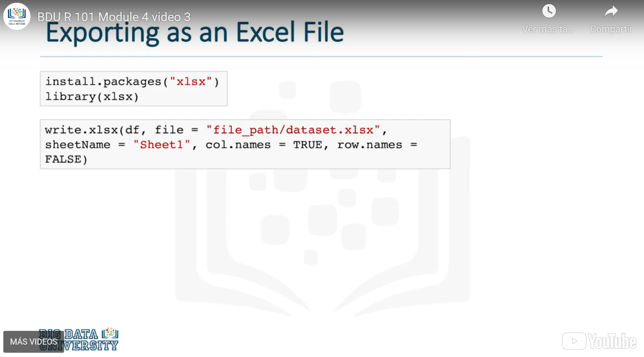

### Saving R objects in .RData files

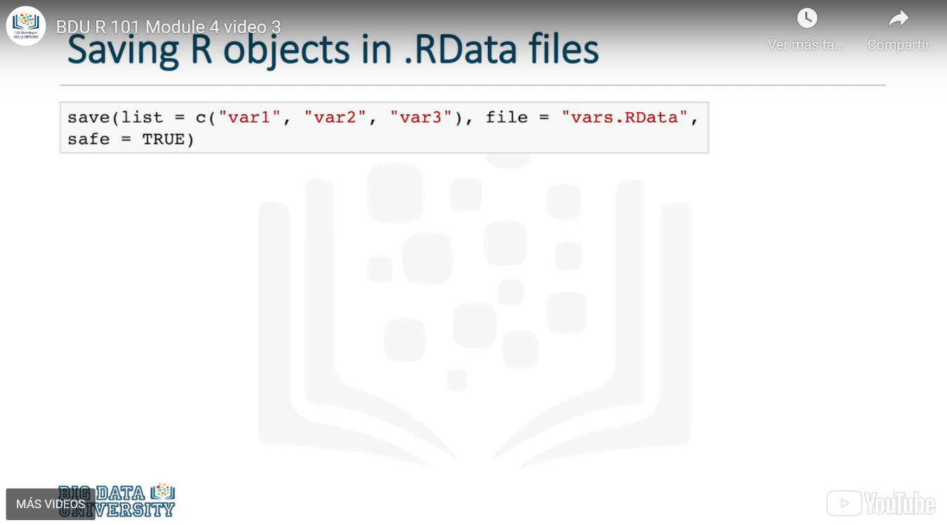

# Strings and Dates in R

## String Operations in R

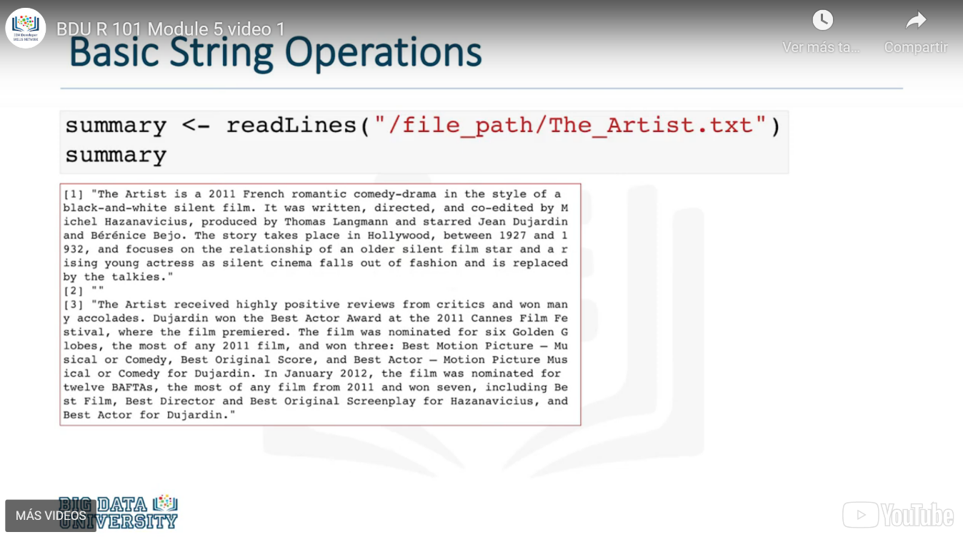

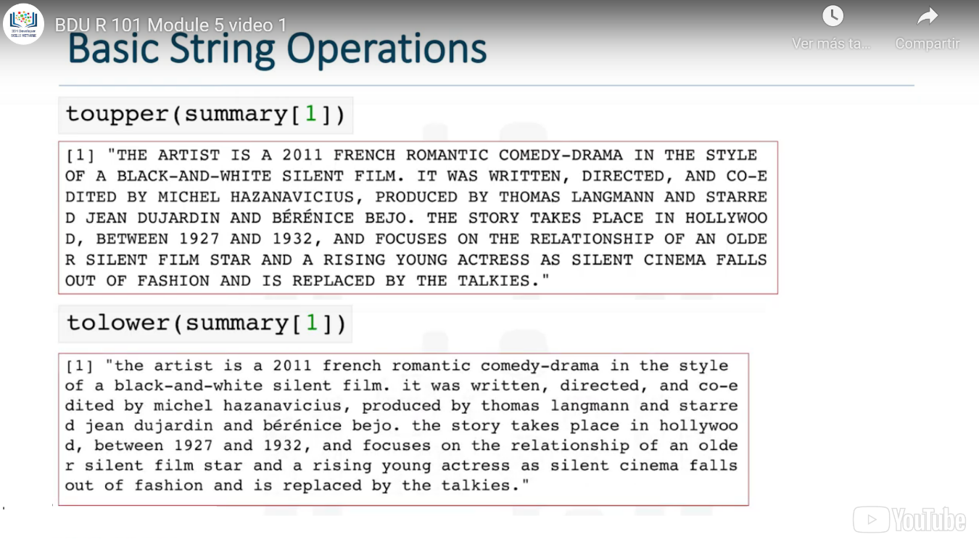

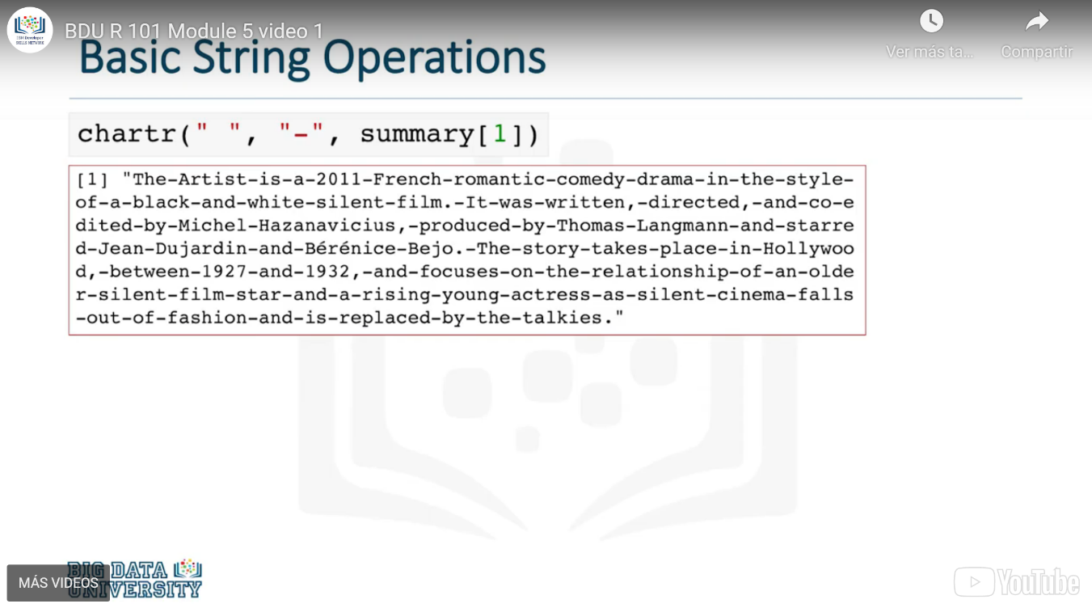

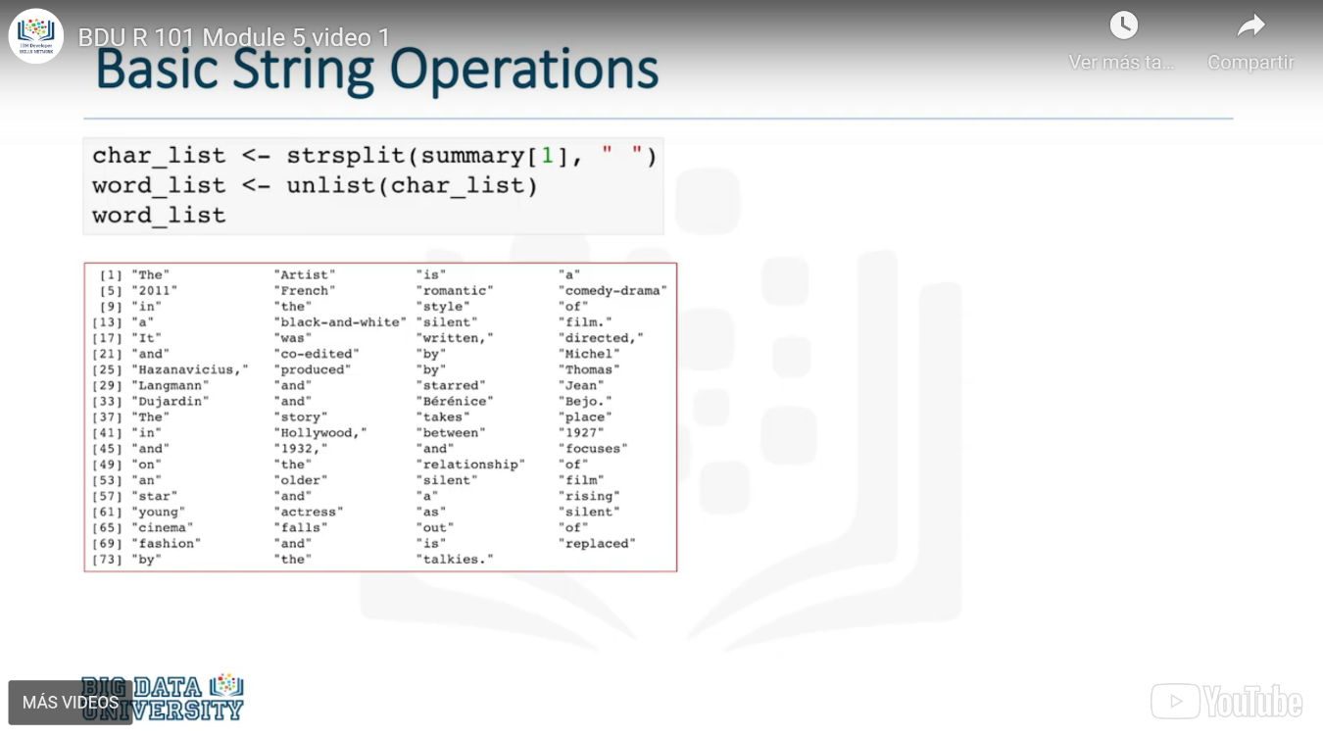

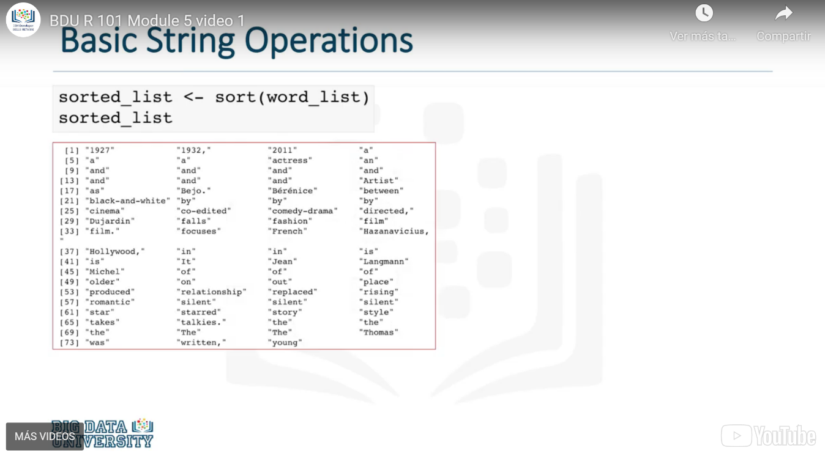

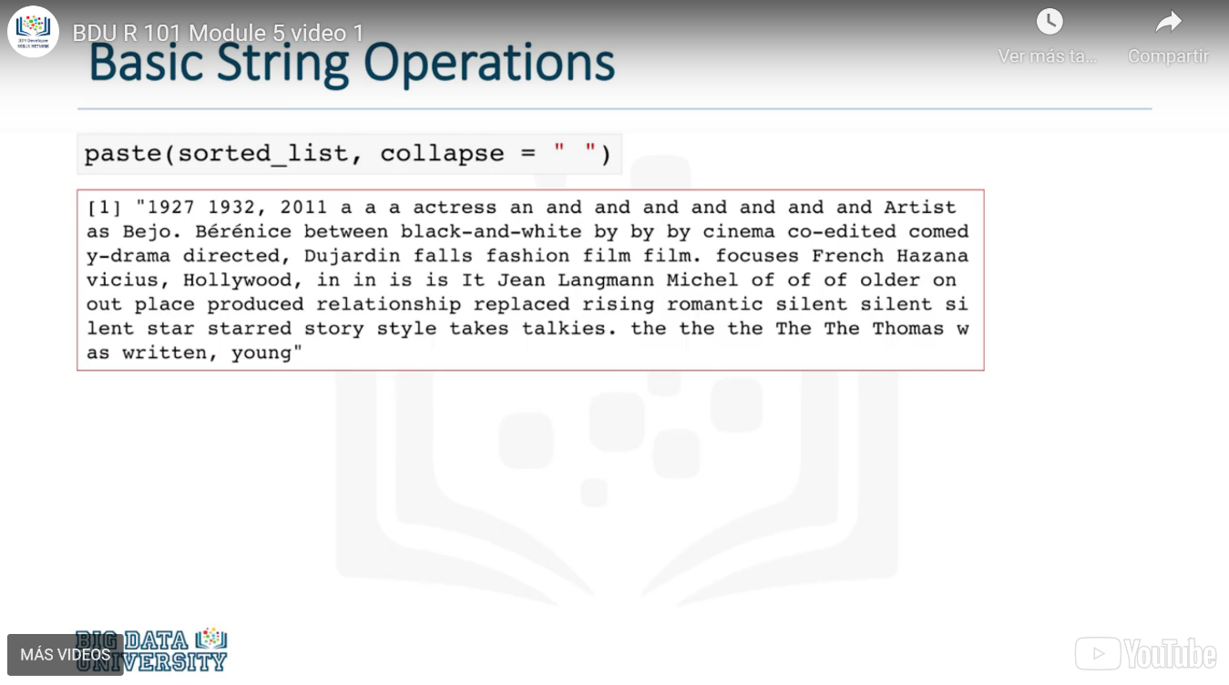

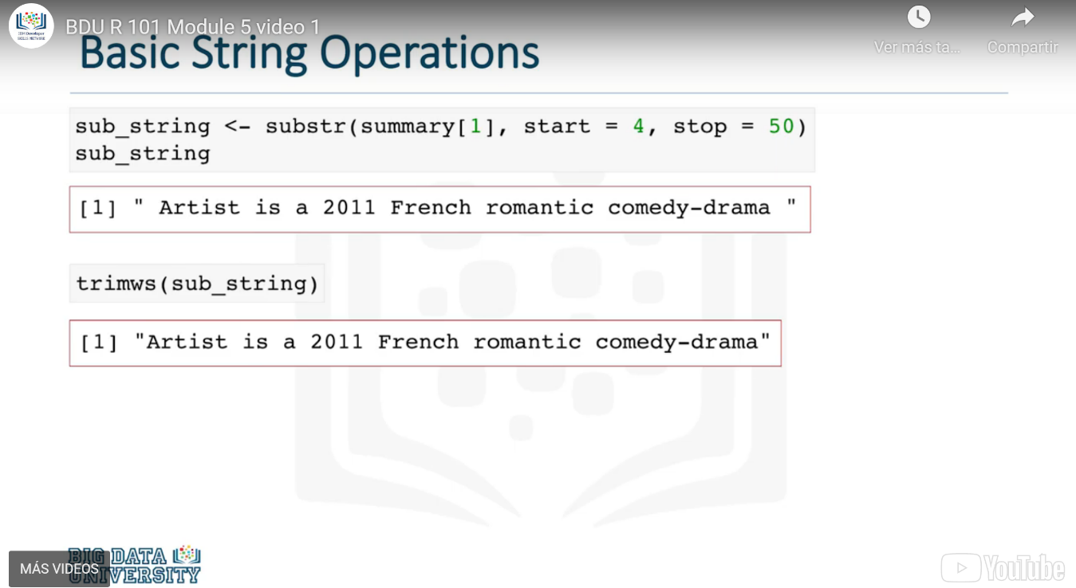

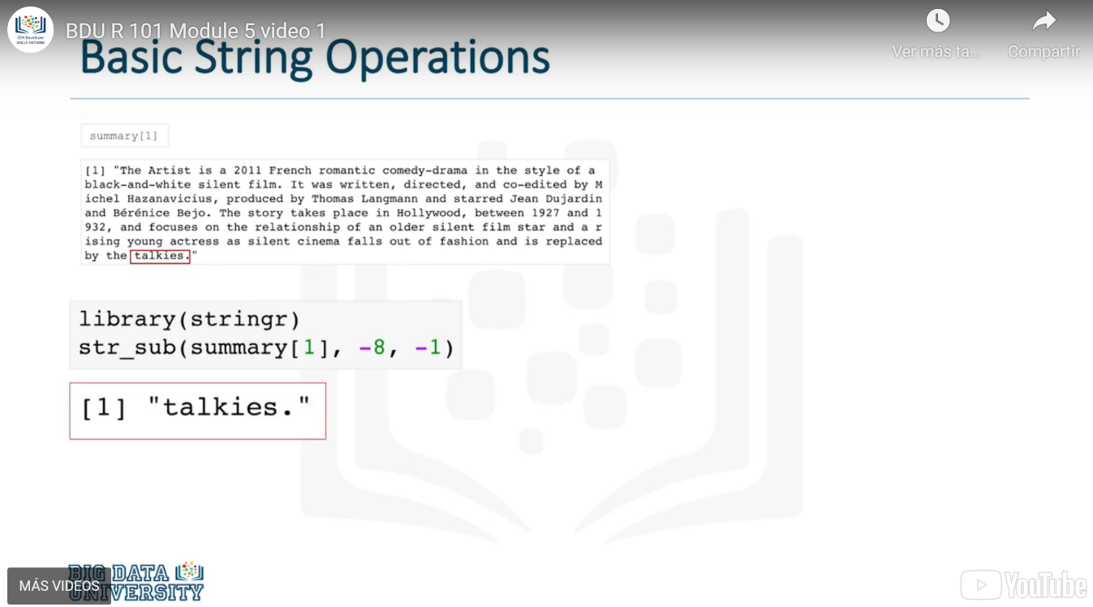

## The Date Format in R

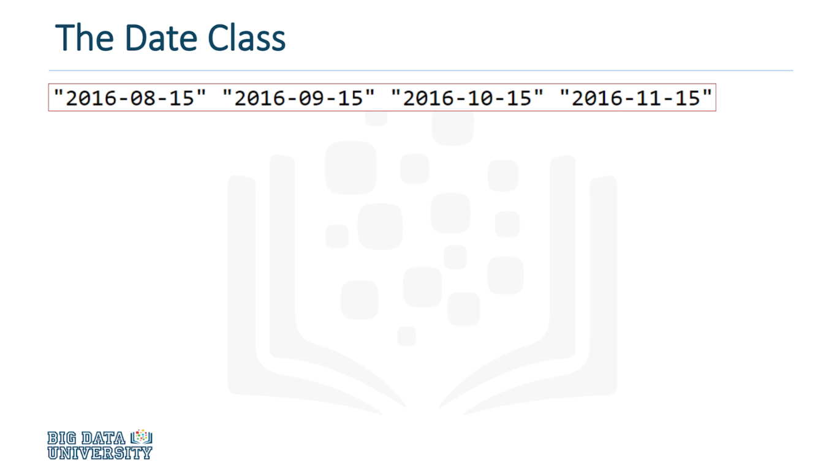

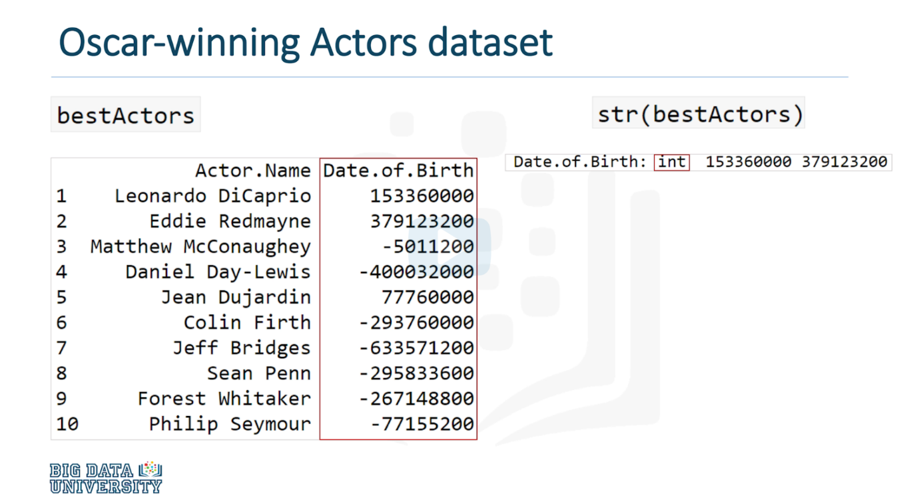

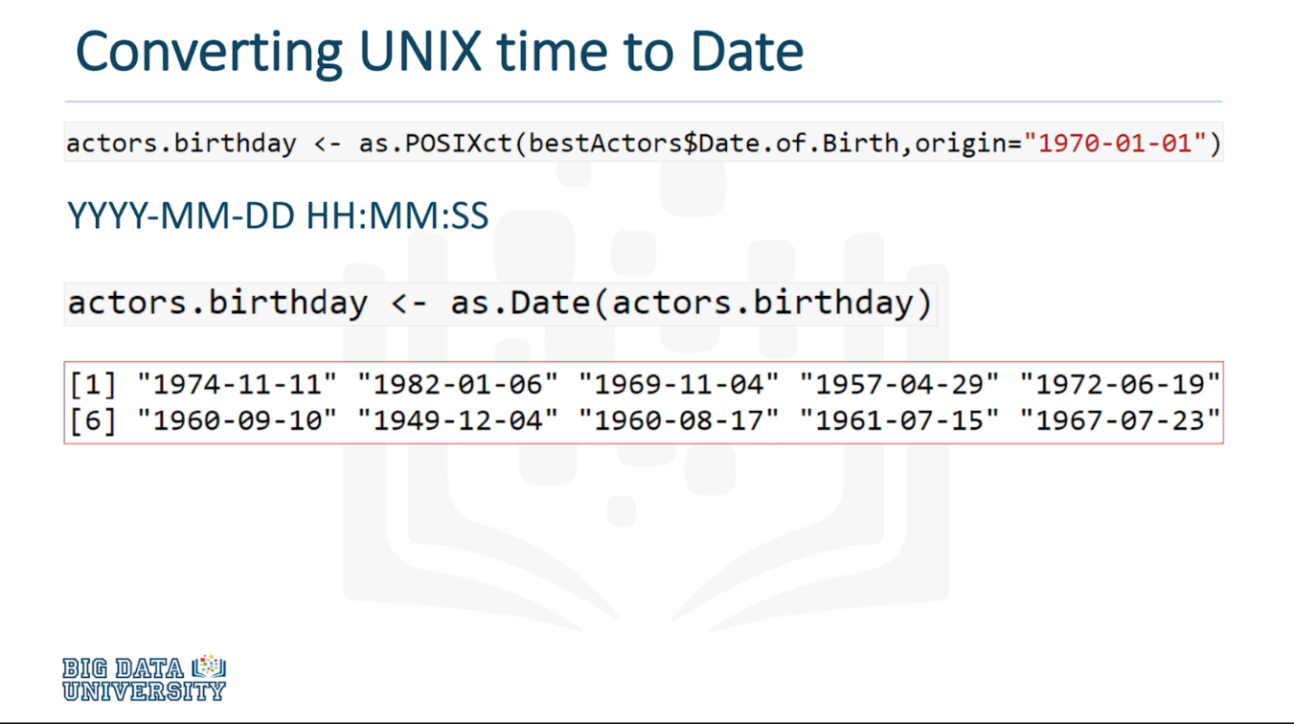

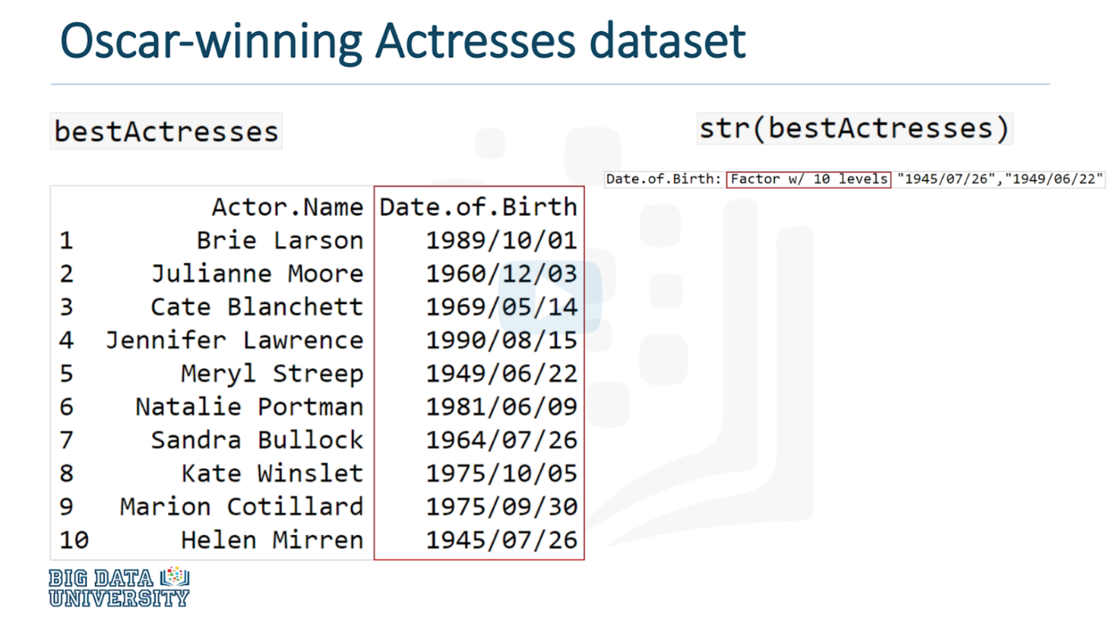

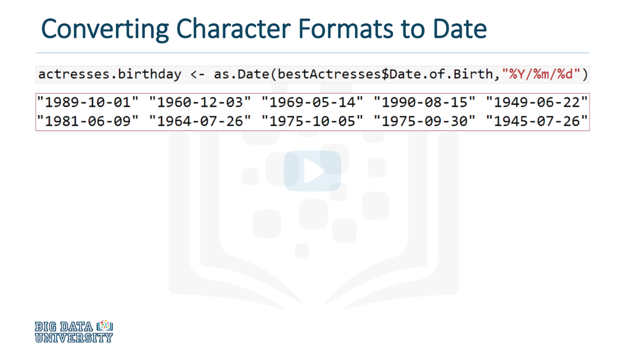

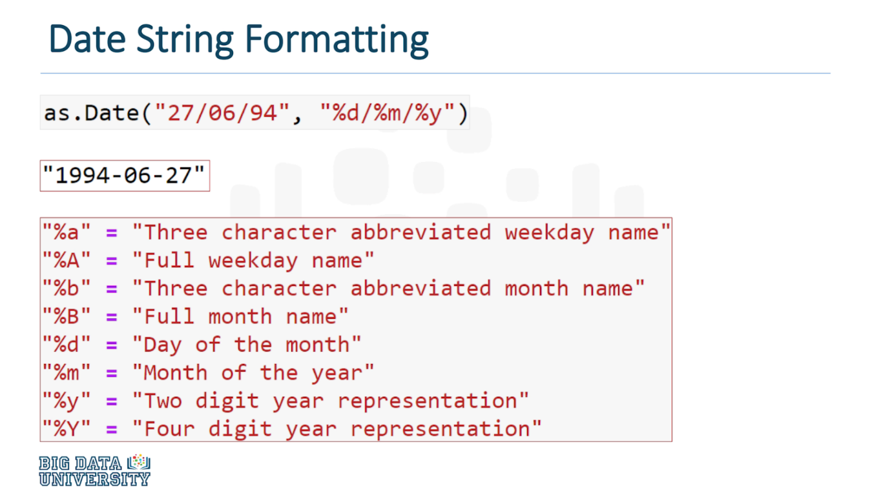

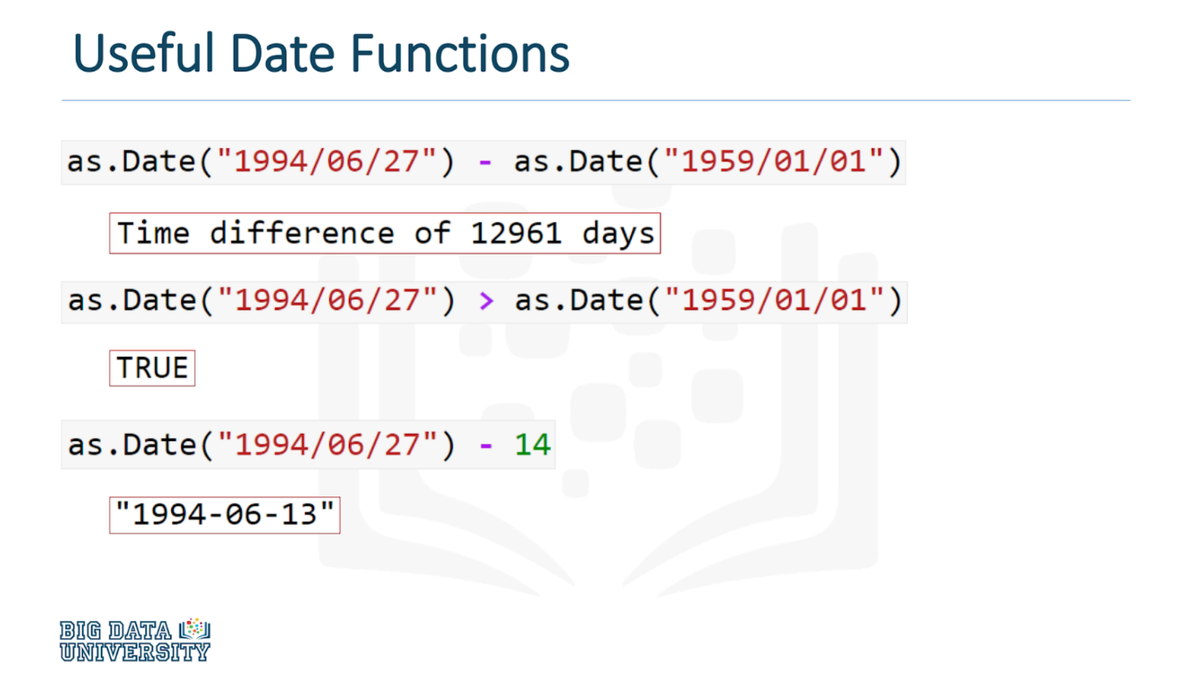

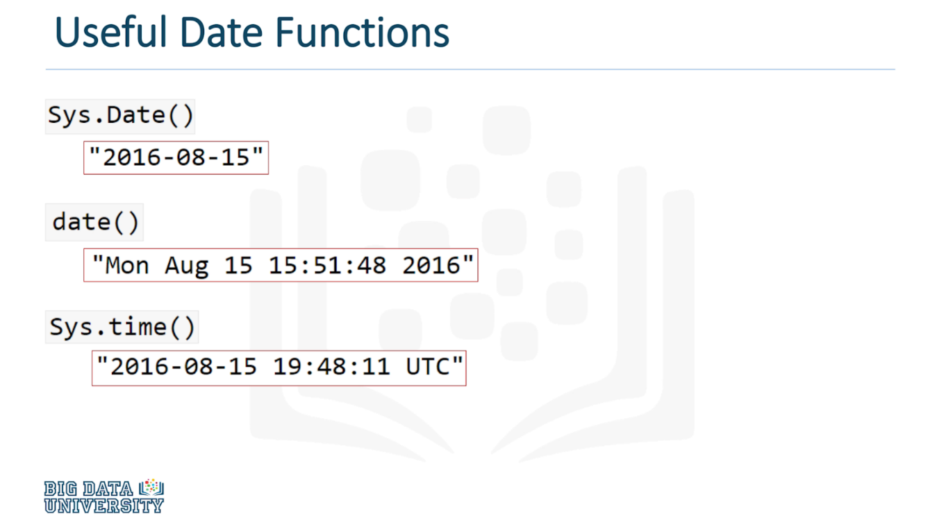

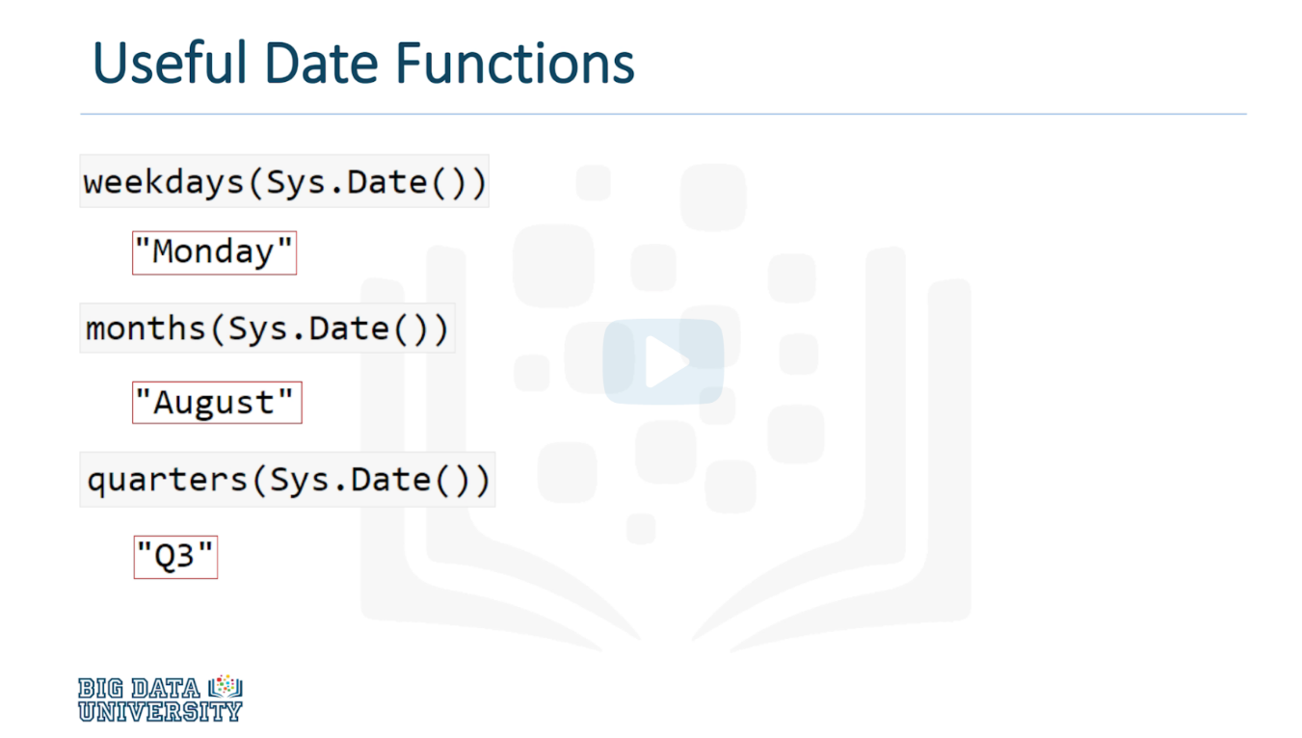

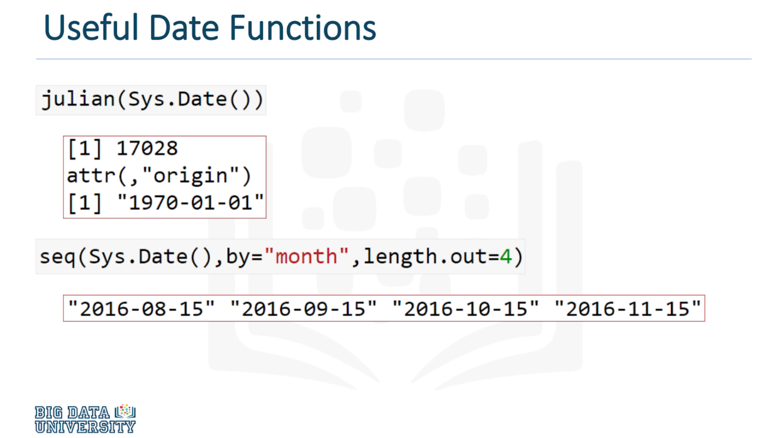

## Regular Expressions in R

Regular expressions are used to match patterns in strings and text.

#### Exercise with a Dataset

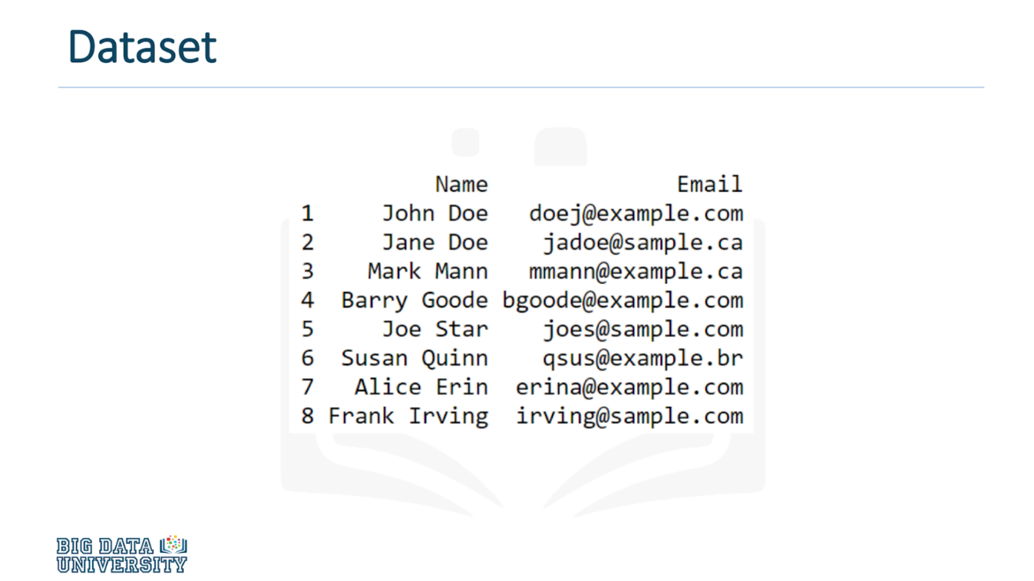

#### Problem

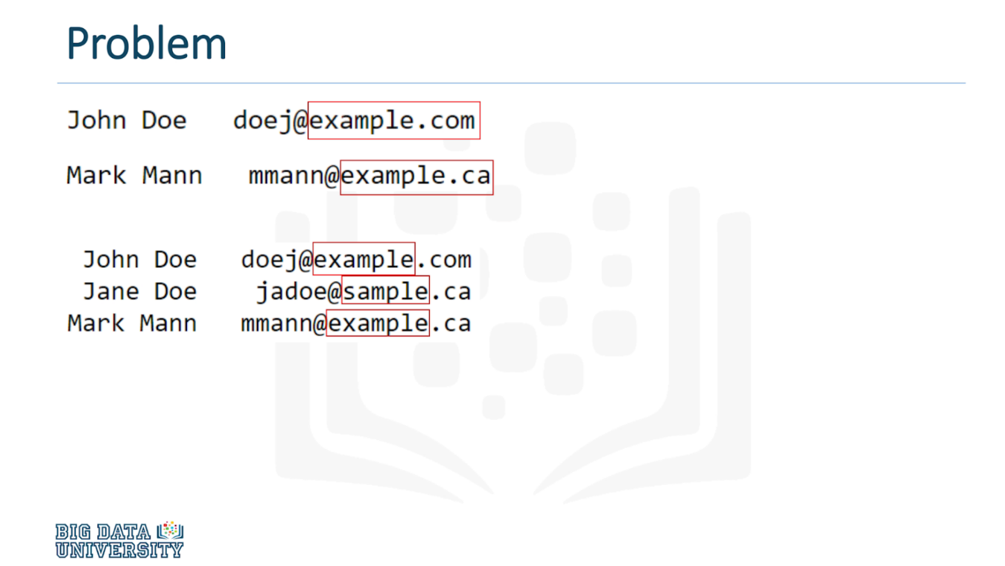

#### How to solve the problem using Regular Expressions

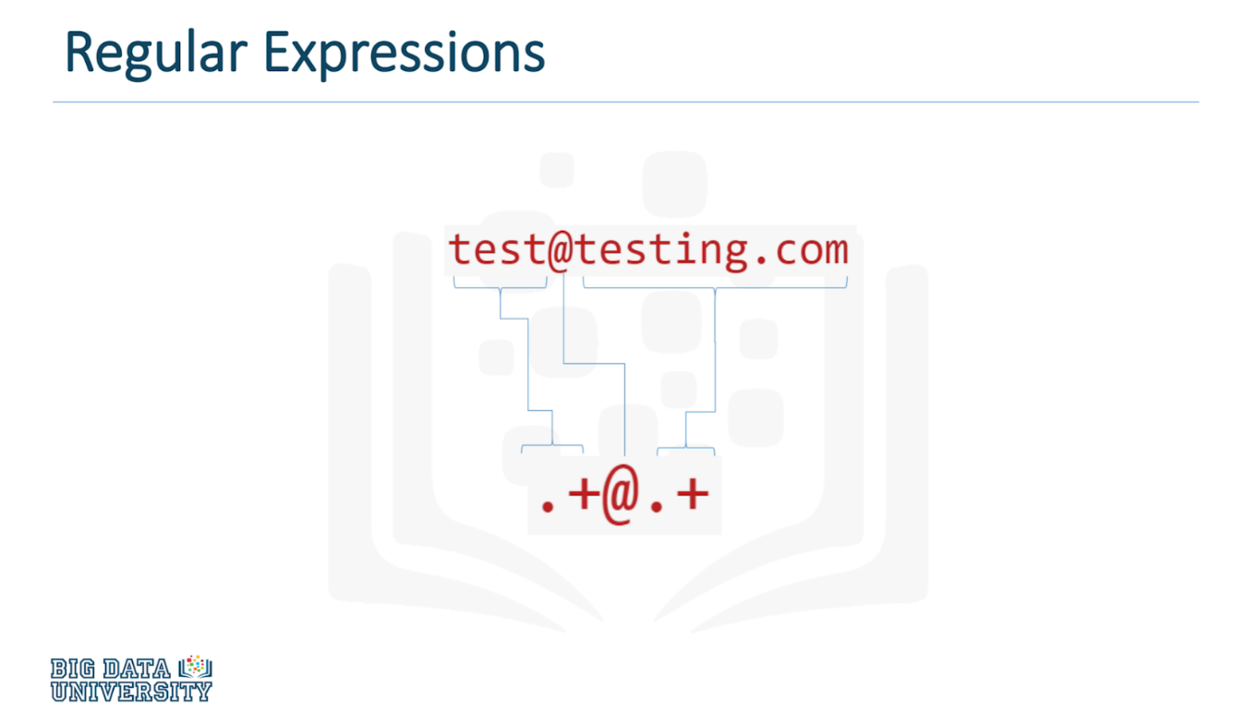

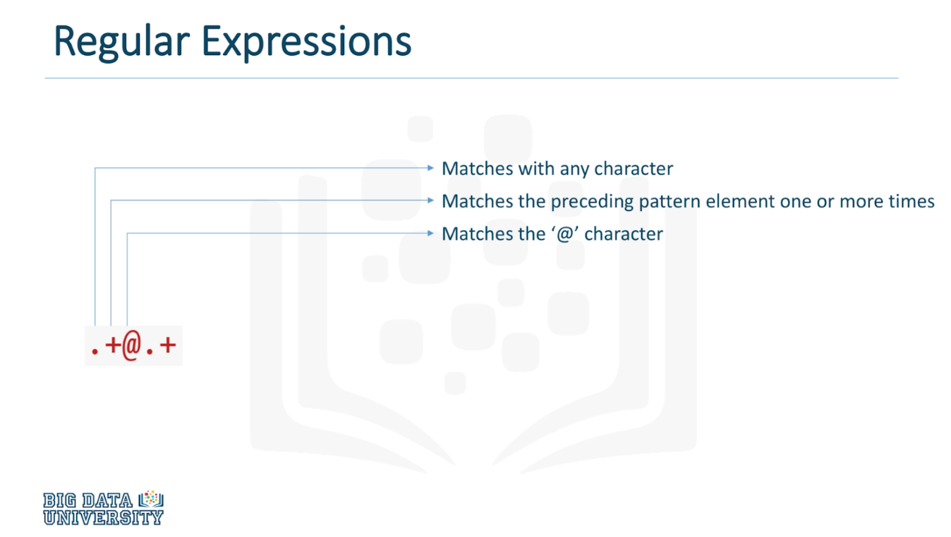

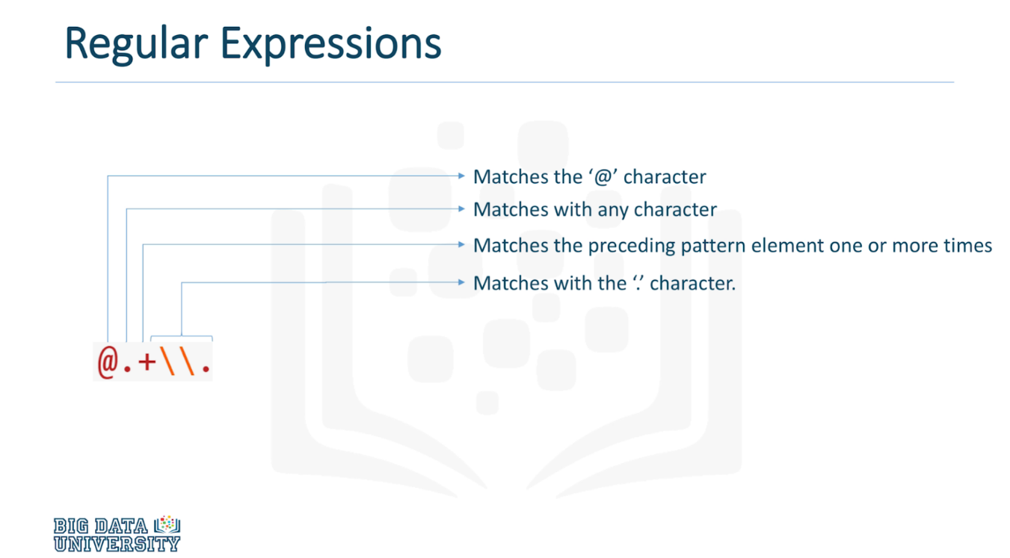

#### Grep funtion

"grep" takes in at least two inputs: The regular expression, and a list of strings you'd like

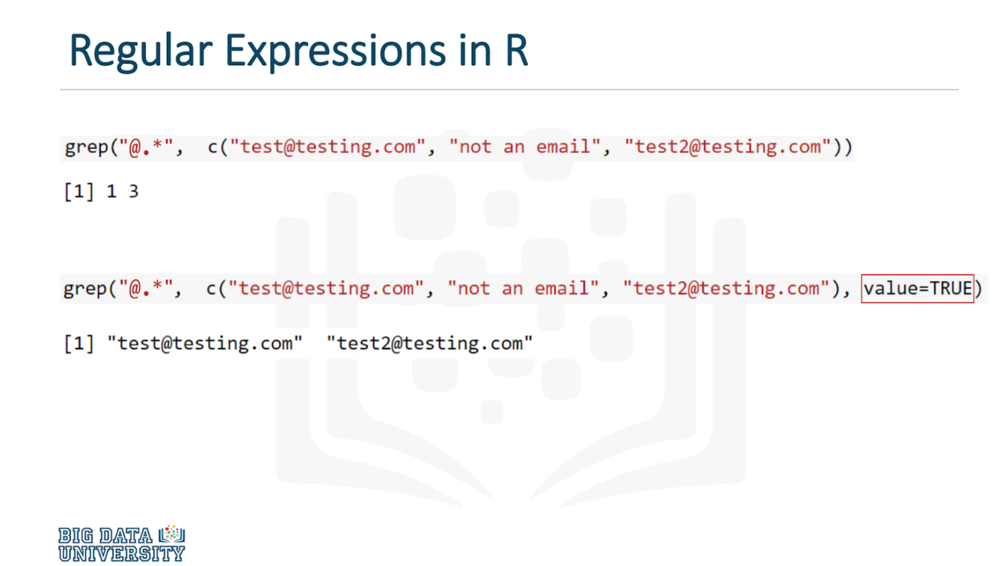

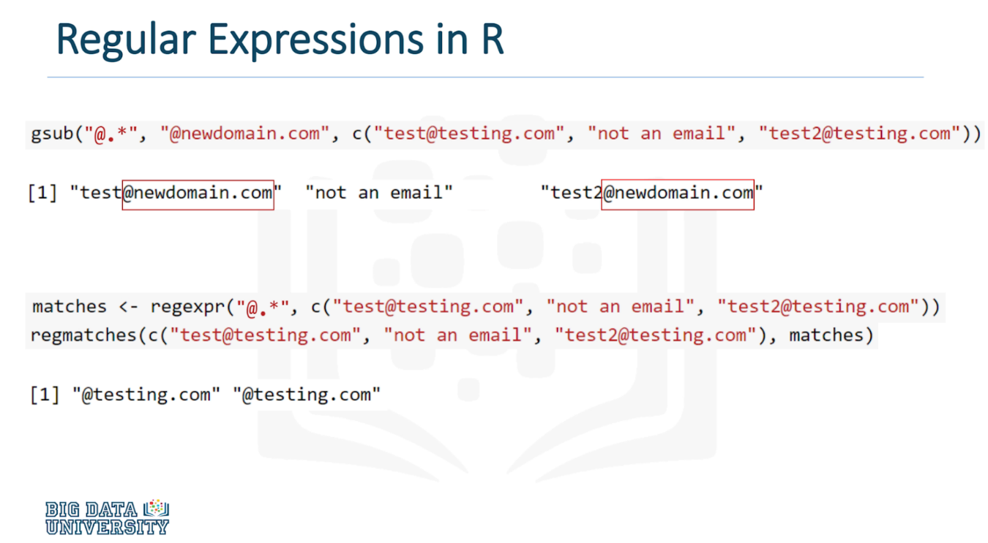

#### Solving the Problem

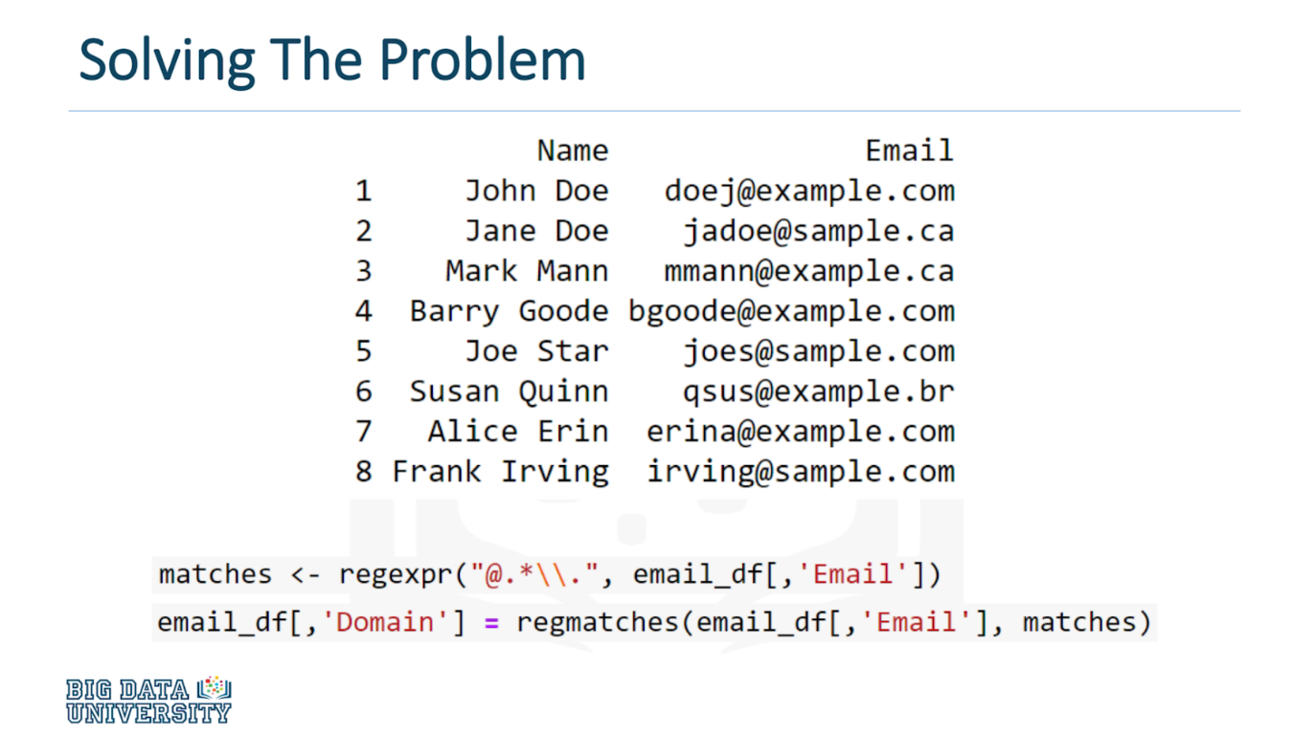

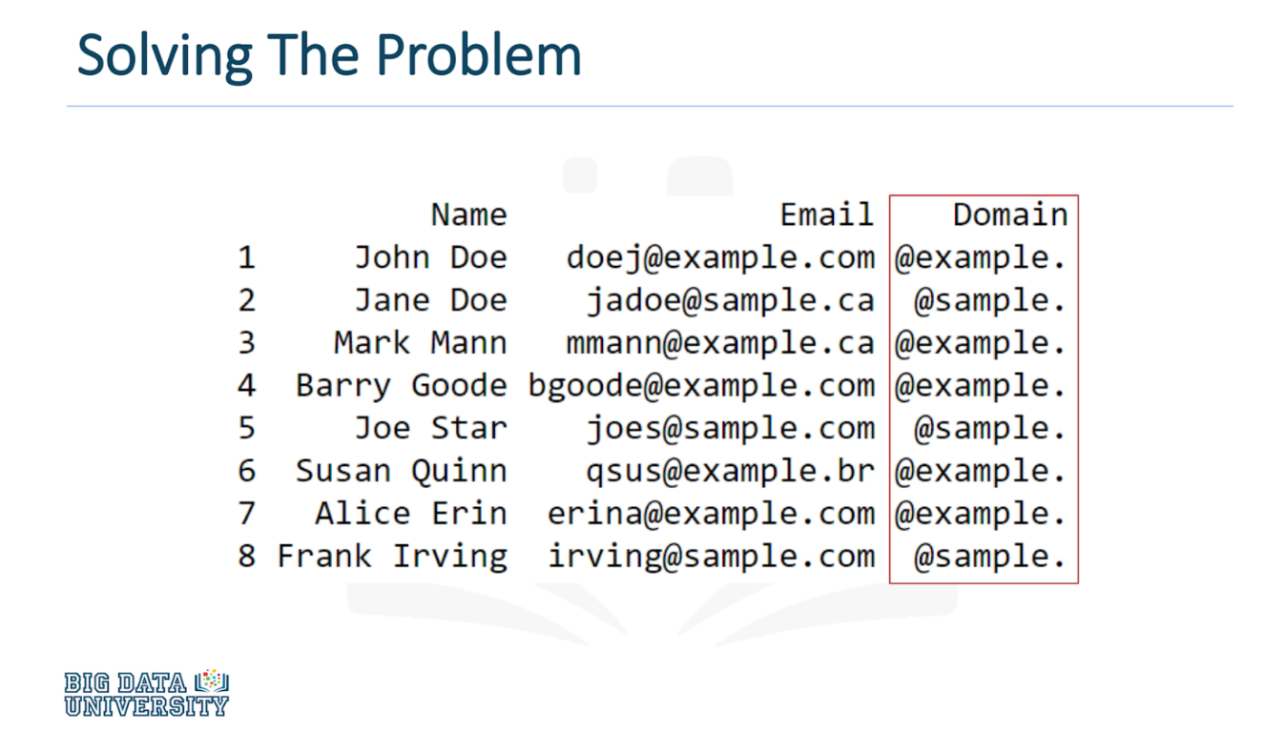

#### Regular Expression Applications

